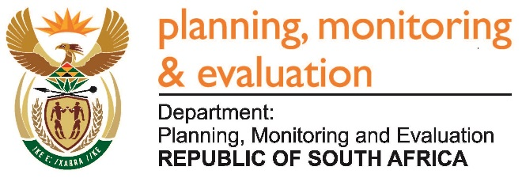 |  | 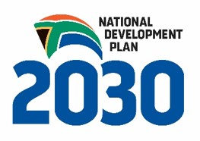
Private Bag X944, PRETORIA, 0001. Union Buildings East Wing, Government Avenue, PRETORIA
Tel: 012 312 0307. www.dpme.gov.za

318. Ms H Bucwa (DA) to ask the Minister in The Presidency:
(1) (a) What is the name of the company and/or companies that was or were appointed to provide services outlined in the Presidency’s Evaluation of Government Business Incentives (DPME-05/2016-17), (b) on what date was the specified appointment made, (c) what is the budget allocated to the contract and (d) by what date is the specified service provider(s) expected to deliver its report;
(2) will he make the specified report available to the public; if not, why not; if so, by what date?
REPLY: NW337E
The name of the company is DNA Economics. It was appointed in December 2016. The budget allocation is R4 393 788, and the report is expected in February 2018. Once the report is approved by cabinet it becomes a public document that is published on the DPME website.

