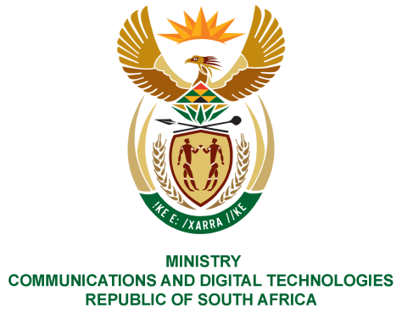
PARLIAMENT OF THE REPUBLIC OF SOUTH AFRICA
NATIONAL ASSEMBLY
WRITTEN REPLY

QUESTION NO: 317
DATE OF PUBLICATION: 19 February 2021
QUESTION PAPER NO: 02
Mr C MacKenzie (DA) to ask the Minister of Communications:
(a) What is the total number of retail post offices in the Republic, (b) of these post offices, what number is (i) SA Post Office (aa) owned and (bb) rented and (ii) postal agencies premises and (c) will she furnish Mr C MacKenzie with an aged analysis of all rentals due to landlords for each retail post office?
NW321E
REPLY:

I have been advised by the SAPO as follows:

- 1 414 Post Offices

(b)(i)
(aa) 458 owned Post Offices
(bb) 956 rented Post Offices

(b)(ii) 694 postal agencies

(c) Age analysis of rentals due as at January 2021 which includes 154 other rented
sites such as mail centres, depot’s box lobbies, etc. (A detailed list is attached hereto)

+30 days | +60 days | +90 days | +120 days | TOTAL
-24 514 125,63 | -26 371 402,36 | -26 803 607,04 | -51 586 293,58 | -129 275 428,61

MS. STELLA NDABENI-ABRAHAMS, MP
MINISTER OF COMMUNICATIONS AND DIGITAL TECHNOLOGIES

