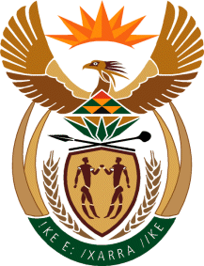

MINISTER IN THE PRESIDENCY: REPUBLIC OF SOUTH AFRICA
Private Bag X1000, Pretoria, 0001, Union Buildings, Government Avenue, PRETORIA
Tel: (012) 300 5200, Website: www.thepresidency.gov.za

NATIONAL ASSEMBLY
WRITTEN QUESTION FOR WRITTEN REPLY

QUESTION NUMBER: 3168
DATE OF PUBLICATIONS: 16 September 2022

3168. Ms C V King (DA) to ask the Minister in The Presidency:
What (a) did the Office of The Presidency contribute towards the funeral of the Enyobeni tavern victims and (b) are the itemised costs associated with the specified funeral? NW3880E

REPLY

(a) There was no contribution from The Presidency

(b) N/A

Thank You.

