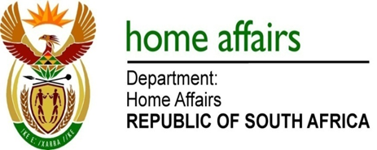

NATIONAL ASSEMBLY

QUESTION FOR WRITTEN REPLY

QUESTION NO. 3160

DATE OF PUBLICATION: Friday, 21 August 2015

INTERNAL QUESTION PAPER 32 OF 2015

3160. Mr A M Figlan (DA) to ask the Minister of Home Affairs:

With regard to his department’s modernisation road map which indicates that the processes of the registration of marriages, issuing of death certificates and application for citizenship will be automated by mid-2015, what measures has his department put in place in respect of (a) infrastructure and (b) policies to meet this target? NW3703E
REPLY:

(a-b) According to the Departmental Strategic Plan 2015–2020 the department has targeted to automate the registration of marriages, divorces, deaths and citizenship business processes by the end of the 2017/2018 financial year. Currently it has only committed to continue with automation of the ID smart card and passport system through live capture in the 2015/2016 financial year. At an appropriate time the department will make further announcement on the modernisation project.

