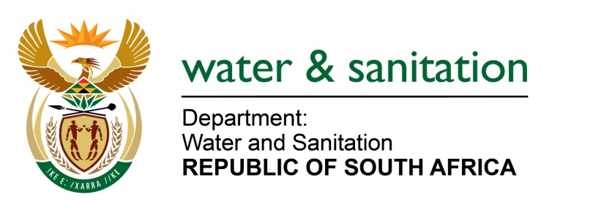

NATIONAL ASSEMBLY

FOR WRITTEN REPLY

QUESTION NO 3155

DATE OF PUBLICATION IN INTERNAL QUESTION PAPER: 20OCTOBER 2017
(INTERNAL QUESTION PAPER NO. 37)
3155. Mr M L Filtane (UDM) to ask theMinister of Water and Sanitation:
(1) When was she informed of the water crisis at the Butterworth Hospital in the Eastern Cape which resulted in patients being discharged to go home and suffer or probably die;
(2) whether she notified the essential services such as the Butterworth Hospital of the water shortage; if not, why not; if so, what are the relevant details;
(3) whether her department has taken any urgent steps to address the water crisis in the specified hospital in order to avoid the loss of lives; if not, why not; if so, what are the relevant details? NW3478E
---00O00---
REPLY:

(1) On 24 January 2017, I was informed of the water crisis pending drought disaster not limited to the Butterworth Hospital but for the entire Butterworth in the Eastern Cape. The Amathole District Municipality (DM) re-declared the drought in January 2017.
(2) Yes, essential services such as the Provincial Department of Health was kept abreast of the unfolding disaster through stakeholder meetings which included the Provincial Drought Technical Task Team, Provincial Sector Departments meetings and Joint Operation Committee meetings held in Butterworth where they were requested to make their own intervention plans as the Amathole DM made it clear that it would not have the capacity to provide the full water demand.
(3) Weekly dam levels have been provided by the Department to the Amathole DM and Provincial Disaster Management Centre. When the situation at Xilinxa Dam supplying Butterworth and surrounding areas became alarming, it was anticipated that it will have serious effect on the hospital and other institutions such as the Walter Sisulu University (WSU) campus. Regular drought water crisis meetings were held with the Amathole DM as the Water Services Authority and other key stakeholders, where they were requested to provide the drought intervention plans.
When the surface water supply to Butterworth (Xilinxa Dam and Gcuwa Dam) ran out completely, the Amathole DM prioritised carting of water to the Hospital. Owing to the logistics and costs of carting water from the nearest alternative source some 30km away, the Amathole DM was unable to meet the full demand at the hospital as well as to provide basic supply to all domestic consumers in Butterworth.

My Department has conducted drought awareness campaigns in Butterworth and has granted permission to the Amathole DM for the re-allocation of the Water Services Infrastructure Grant (WSIG) funding to accommodate emergency water supply in Butterworth through the Butterworth Emergency Water Supply Scheme (pipeline from Tsomo River to Xilinxa Dam), water tankering and groundwater investigations, namely, hydrogeological investigations, drilling, testing and equipping of boreholes at Butterworth, Kotana, Ehlobo, Teko Springs and WSU.
My Department approached the Office of the Premier, Provincial Department of Cooperative Governance and Traditional Affairs (CoGTA) and Provincial Treasury; as a result an amount of R 3 million has been pledged to assist Amathole DM with the drought.
Fortunately the water outage was short lived and the rain which fell from
8 to 9 October 2017 brought relief and the Gcuwa Dam was filled, but the Xilinxa Dam only rose to 7%, which will provide approximately 3 months supply. Butterworth is therefore not out of the crisis yet and needs close monitoring hence my Department has allocated Amathole DM with ten water tankers.
---00O00---

