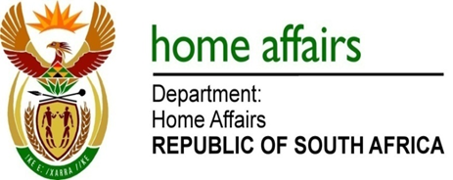

NATIONAL ASSEMBLY

QUESTION FOR WRITTEN REPLY

QUESTION NO. 3155

DATE OF PUBLICATION: Friday, 14 August 2015

INTERNAL QUESTION PAPER 30 OF 2015

3155. Mr M H Hoosen (DA) to ask the Minister of Home Affairs:

With regard to the IT server at the (a) Edenvale Home Affairs office and (b) Kempton Park Home Affairs office, (i) what amount of down-time or server failure has been experienced by each office’s IT server in (aa) 2014 and (bb) since 1 January 2015, (ii) what was the length of time of each down-time and (iii) what was the reason for each down-time? NW3698E
REPLY:

- The information for both offices is hereby provided as follows:
- Edenvale:
(aa) 2014 - none
(bb) April 2015 – one (1),
June 2015 – seven (7),
July 2015 - eight (8) and
August 2015 two (2).

- Kempton Park:
(aa) April 2014 - six (06),
(bb) May 2015 - four (4),
June 2015 - three (3),
July 2015 – six (06) and
August 2015 – two (2).

(ii-iii) Details in tabular format attached below:

OFFICE | MONTH | FREQUENCY OF DOWNTIMES | Duration of Down Time | Reason for Down Time
EDENVALE | APRIL 2015 | 01 | The whole day | Photo booth and Front Line Officer (FLO) workstation offline/ power off
 | JUNE 2015 | 07 | The whole day | FLO workstation and photo booth offline
 | JULY 2015 | 08 | The whole day | Photo booth offline and Integrated Receipting Engine (IRE) for cash registers faulty
 | AUGUST 2015 | 02 | The whole day | Integrated Receipting Engine (IRE) faulty. Photo booth offline and Xerox was faulty
KEMPTON PARK | APRIL 2015 | 06 | 2 Hours | Server was down due upgrade and generator kick in
 | MAY 2015 | 04 | 3 Hours | Problem with Server and generator failed to kick in
 | JUNE 2015 | 03 | 3 Hours | Problem with server generator failed to kick in
 | JULY 2015 | 06 | The whole day | Back Office re-started the server
 | AUGUST 2015 | 02 | 3 Hours | Problem with server generator failed to kick in

