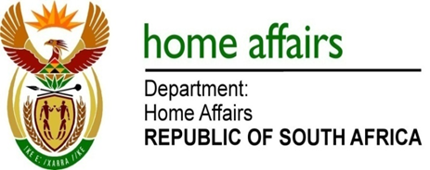

NATIONAL ASSEMBLY

QUESTION FOR WRITTEN REPLY

QUESTION NO. 3149

DATE OF PUBLICATION: Friday, 21 August 2015

INTERNAL QUESTION PAPER 32 OF 2015

3149. Mrs D Robinson (DA) to ask the Minister of Home Affairs:

How many (a) cases of human trafficking did immigration officials on the borders of (i) Lesotho and (ii) Swaziland detect in the (aa) 2010-11, (bb) 2011-12, (cc) 2012-13, (dd) 2013-14 and (ee) 2014-15 financial years and (b) of the specified instances involved female victims? NW3692E
REPLY:

(a)(i-ii) The immigration officials working on the borders of Lesotho and Swaziland have not reported any cases specifically relating to human trafficking in the mentioned financial years.

