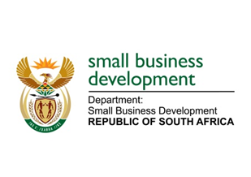

**NATIONAL ASSEMBLY**

**QUESTION FOR WRITTEN REPLY**

**DUE IN PARLIAMENT: 30 SEPTEMBER 2022**

**“3141. Mr H C C Krüger (DA) to ask the Minister of Small Business Development:**

**What total number of (a) small, (b) medium and (c) micro enterprises have registered as formal businesses (i) in each year and (ii) for each industry since she took Office?”**

**NW3850E**

**REPLY: I have been advised by the department as follows:**

Since the Minister took office (August 2021) no study has been conducted on SMMEs that have registered as formal businesses. The only study which was conducted was in partnership with Fin scope South Africa during 2021/22 financial year which has estimated the total number of SMMEs that have registered as formal businesses at 2 615 715. The study segmented micro enterprises at 2 219 026, small enterprises at 375 809 and medium-sized enterprises at 20 916, full details of each category are outlined below.

Table 1: Small Enterprises by category and number of employees



Additionally, small enterprises operate mainly within the services and trade industries whilst medium-sized enterprises are predominantly within the industrial sector. In terms of the study the industries/sectors of operation are as follows: majority of micro and small enterprises operate within the services sector/industry as well as trade, whilst medium enterprises are within the industrial sector.

**STELLA NDABENI-ABRAHAMS**

**MINISTER: SMALL BUSINESS DEVELOPMENT**