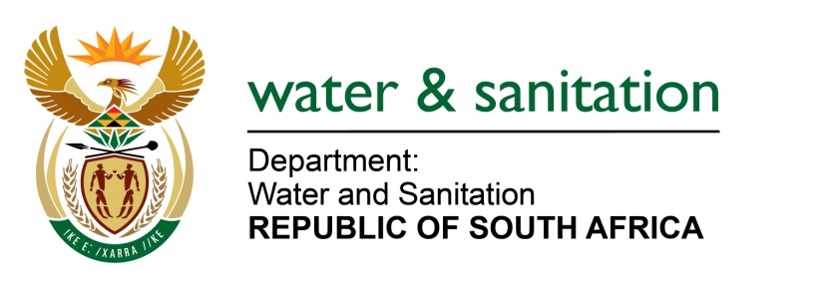

NATIONAL ASSEMBLY

FOR WRITTEN REPLY

QUESTION NO 3130

DATE OF PUBLICATION IN INTERNAL QUESTION PAPER: 16 SEPTEMBER 2022
(INTERNAL QUESTION PAPER NO. 33)

3130. Ms A M M Weber (DA) to ask the Minister of Water and Sanitation:
(1) With reference to his reply to question 2284 on 26 August 2022, what steps will he and/or his department take to assist the community of Doornkop in Gauteng that needs help with water supply, as the local municipality does not have sufficient water supply and service delivery is lacking.
(2) what intervention measures will he put in place to provide water to the entire area, as the current boreholes cannot meet the demand and the occupants of the informal part of Doornkop are connecting pipes to the main water supply line, and they use all the water before it reaches the community.
(3) whether she has been informed that on 19 September 2020 a notice was intended to be delivered to the occupiers of Doornkop who illegally connected to the borehole; if not, what is the position in this regard; if so, (a) on what date was the specified notice served, (b) will she furnish Ms A M M Weber with a copy of the notice and (c) how will she ensure that the notice will be enforced?

---00O00---

MINISTER OF WATER AND SANITATION

- The source of drinking water for Doornkop area is potable water that is supplied through a reticulation network system from Doornkop Reservoir. The water supply capacity and infrastructure servicing Doornkop is deemed adequate as there have been no documented prolonged water outages that could point to supply limitations.
(2) Information received from Johannesburg Water is that there are no boreholes in Doornkop. The City of Johannesburg Water supplies water to the informal settlements in the area through standpipes or stationary water tanks which are filled by mobile water tankers on a regular basis.
(3) Not applicable.

---00O00---

