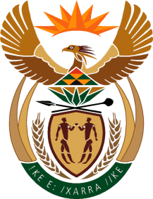

MINISTRY OF TOURISM
REPUBLIC OF SOUTH AFRICA

Private Bag X424, Pretoria, 0001, South Africa. Tel. (+27 12) 444 6780, Fax (+27 12) 444 7027
Private Bag X9154, Cape Town, 8000, South Africa. Tel. (+27 21) 469 5800, Fax: (+27 21) 465 3216

NATIONAL ASSEMBLY:

QUESTION FOR WRITTEN REPLY:
Question Number: 312
Date of Publication: 17 February 2023
NA IQP Number: 2
Date of reply: 27 February 2023

Mr K P Sithole (IFP) to ask the Minister of Tourism:

Whether there are any programmes available to those in the small-scale hospitality industry to access government funding in order to mitigate the impact of load shedding; if not, why not; if so, what are the relevant details? NW326E

REPLY:

Through the Green Tourism Incentive Programme (GTIP) the Department offers partial grant funding support on the cost of retrofitting tourism facilities with energy and water efficiency equipment and systems based on the outcome of a resource efficiency audit. Those in the small-scale hospitality industry can apply for the GTIP. The GTIP is housed, managed and administered by the IDC and all applications to the programme is received, processed and managed by the IDC. The department is, however, directly involved in the final adjudication of grant funding support for eligible and qualifying applications as part of the GTIP adjudication panel made up of members from the IDC and the department.

