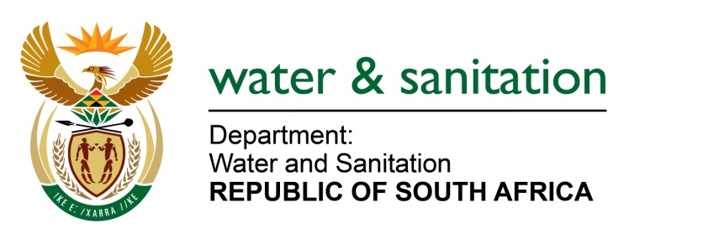

NATIONAL ASSEMBLY

FOR WRITTEN REPLY

QUESTION NO 3118

DATE OF PUBLICATION IN INTERNAL QUESTION PAPER: 21 AUGUST 2015
(INTERNAL QUESTION PAPER NO. 32)

3118. Mr P G Atkinson (DA) to ask the Minister of Water and Sanitation:
Whether her department has any plans to provide water and sanitation to the residents of Eikenhof informal settlement in Southern Johannesburg; if not, why not; if so, what are the relevant details? NW3659E
---00O00---
REPLY:

The City of Johannesburg is the Water Service Authority which provides services to the Eikenhof informal settlement in the southern part of Johannesburg. The City of Johannesburg through the Joburg Water is providing the following basic water and sanitation services:

- 6 Communal stand-pipes for water; and
- 500 Ventilated Improved Pit-latrines (VIP’s).

The City of Johannesburg/ Joburg Water has plans in place to install 400 VIP in the current 2015/16 financial year.

---00O00---

