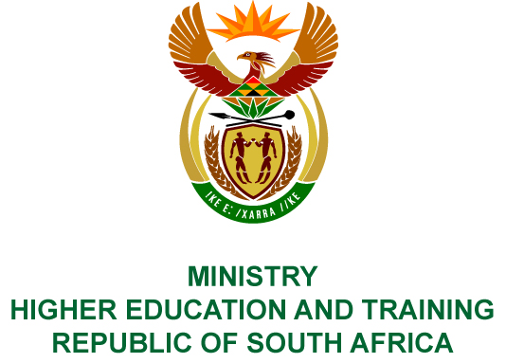
Private Bag X893, Pretoria, 0001, Tel (012) 312 5555, Fax (012) 323 5618
Private Bag X9192, Cape Town, 8000, Tel (021) 469 5150, Fax: (021) 465 7956
Memorandum from the Parliamentary Office
NATIONAL ASSEMBLY
FOR WRITTEN REPLY
QUESTION 3111
DATE OF PUBLICATION OF INTERNAL QUESTION PAPER: 26/10/2018
(INTERNAL QUESTION PAPER NO 35 OF 2018)
Mr M R Bara (DA) to ask the Minister of Higher Education and Training:
Whether, since she served in Cabinet, she (a)(i) was ever influenced by any person and/or (ii) influenced any of her department’s employees to take any official administrative action on behalf of any (aa) member, (bb) employee and/or (cc) close associate of the Gupta family and/or (b) attended any meeting where any of the specified persons were present; if so, what are the relevant details in each case?
NW3476E
REPLY:
- (i) No.
(ii) No.
(aa) No.
(bb) No.
(cc) No.
- No.

