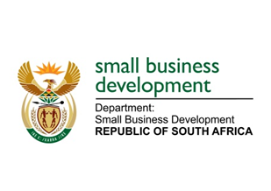
NATIONAL ASSEMBLY
QUESTION FOR WRITTEN REPLY
DUE IN PARLIAMENT: FRIDAY, 3 MARCH 2023

“311. Inkosi B N Luthuli (IFP) to ask the Minister of Small Business Development: Whether, with reference to the statistic that 70 to 80% of small and medium enterprises (SMEs) in the Republic fail within their first five years, her department has found the specified statistic to be a reflection on its failures to invest and timeously implement protective and growth-inducing measures for SMEs; if not, what is the position in this regard; if so, what are the relevant details?” NW325E

REPLY: I have been advised by the department as follows:

The Annual report produced by the Department of Small Businesses Development asserts that the statistic that 70-80% of SMEs in the Republic fail within first five years, is not only a South African phenomenon, but is a global one. This aspect is also confirmed by the European Commission and United States Bureau of Labour Statistics (2019). Therefore, the phenomenon of high failure rates for small businesses in South Africa should be understood in this context.

Further, the demise of the SMEs in the first few years of existence cannot be attributed to DSBD as their support emanates from all government departments and entities as well as the private sector in various forms and methods.

It is normally posited that the high failure rate amongst small businesses in South Africa are due to challenges such as lack of access to finance, caused by stringent requirements by financial institutions; inability to access markets triggered by dominance of large firms; lack of knowledge/skills; regulatory burdens such as labour laws that unintentionally discourage entrepreneurs from employing workers; inadequate infrastructure and high crime rate. The impact of COVID-19 has also exacerbated this failure rate as per study by World Bank Group and DSBD (2022), reflecting low sales levels with 4 out of 5 firms (80%) reporting sales being down compared to pre-pandemic levels as reflected below.

The Department also recognises the importance of ensuring that entrepreneurs that have experienced an honest business failure, can be given an opportunity to wind up previous businesses and be given a ‘second chances’ through being treated in the same way as new start-ups of receiving various financial and non-financial support by the DSBD’s agencies i.e., small enterprise development agency (Seda) and the small enterprise finance agency (sefa).

STELLA NDABENI-ABRAHAMS
MINISTER: DEPARTMENT OF SMALL BUSINESS DEVELOPMENT

