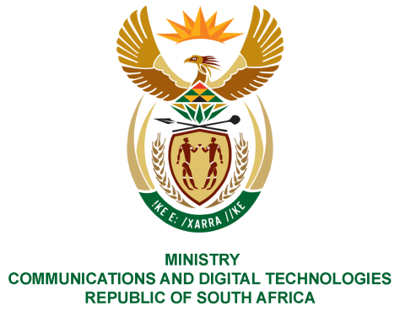
PARLIAMENT OF THE REPUBLIC OF SOUTH AFRICA
NATIONAL ASSEMBLY
WRITTEN REPLY

QUESTION NO: 311

Mr C MacKenzie (DA) to ask the Minister of Communications:

(1) What is the total number of social grant recipients who are being paid (a) through the SA Post Office channels, (b) in cash, (c) via SA Social Security Agency card and (d) directly into bank transactional and/or credit card accounts;

(2) What (a) total number of cash payment points are currently being used and (b) are the total costs of each pay point per month, since the inception of the SA Post Office and the Department of Social Development agreement NW465E

REPLY:

I have been advised by SAPO as follows:

- (a,b,c) In terms of payments SAPO has information as per “Withdrawal transactions” and not beneficiary numbers. The reason for this is that one beneficiary is doing more than 1 transaction in a month (balance enquiry, 2x withdrawals maybe, and so forth). Out of 8,1 million beneficiaries SAPO paid during the month of February 2020, total transactions that were done were 63,155,360 which far exceed the 8,1 grants that gets paid through SAPO channel. However, SAPO is able to ascertain that of this transaction total 57,97% make use of ATMs, 31,55% use Retailers; those that access their grants making use of SAPO branches and CPPs are 4,38% and 7,50% respectively. These figures fluctuate slightly around these percentages on monthly basis.

(d) SAPO disburse to Special Disbursement Accounts (SDA – commonly known as a SASSA Cards). SASSA client (beneficiaries) that are not using SDA are handled direct by SASSA through their EFT process to their bank accounts. SAPO is not privileged to those numbers.

- a) SAPO is contracted to service 1740 Cash Pay Points (CPPs) with SASSA.
- The cost of cash pay points since inception is R962 million: September 2018 to March 2019: R267 million; 2019/20 Financial Year is R695 million. The average cost of each Cash Pay Point per month is R40, 000 (17,703 CPPs (Apr – Feb) / R695m = R39,259).

MS. STELLA NDABENI-ABRAHAMS, MP
MINISTER OF COMMUNICATIONS AND DIGITAL TECHNOLOGIES

