NATIONAL ASSEMBLY
QUESTION FOR WRITTEN REPLY
QUESTION NUMBER: 311 [NW320E]
DATE OF PUBLICATION: 19 FEBRUARY 2016

311. Ms T Stander (DA) to ask the Minister of Finance:
(1) What was the value of current (a) assets, (b) liabilities and (c) liquidity ratio in each metropolitan municipality in the (i) 2013-14 and (ii) 2014-15 financial years;
(2) what were the reasons of each specified municipality’s inability to recover short-term debt for the specified financial years, if the ratio was lower than 1:00? NW320E
REPLY:

(1)(a)(i) and (ii) and (b)(i) and (ii). The current assets and liabilities for the metropolitan municipalities for 2013/14 and 2014/15 is contained and presented in the table below:
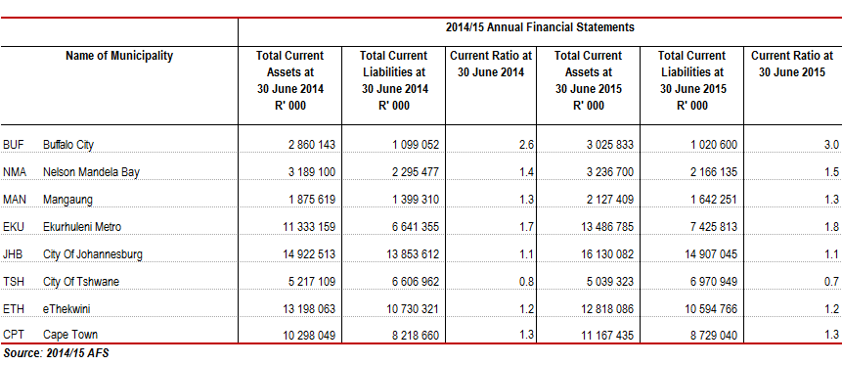

(2) The liquidity position is measured using current ratio which assesses the municipality’s ability to pay back its short-term liabilities with its short-term assets. From the table above, it can be seen that all the metropolitan municipalities with the exception of City of Tshwane have current assets that exceed the current liabilities (current ratio larger than1:1). This indicates that they are able to meet their current obligations.

The case with the City of Tshwane is that the cash and cash equivalents at year end were R600 million and was not sufficient to pay current commitments. The reasons for this are: The realised consumer collection rate of 94 per cent is not sufficient to pay for all commitments. The outstanding debtors has increased year-on-year showing that the city is not collecting long outstanding debtors at an increasing rate. The possible solutions are: The municipality must decrease commitments to the maximum income realised and /or must recover more than 94 per cent in order to meet its commitments.

