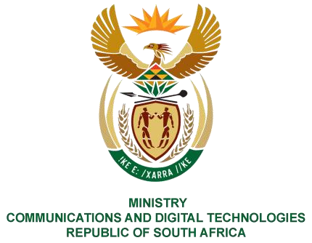
PARLIAMENT OF THE REPUBLIC OF SOUTH AFRICA
NATIONAL ASSEMBLY
WRITTEN REPLY
QUESTION NO: 310
DATE OF PUBLICATION: 17 February 2023
QUESTION PAPER NO: 02
Ms Z Majozi (IFP) to ask the Minister of Communications and Digital Technologies:
Whether, following reports that Cabinet approved the roll-out of the second phase of the SA Connect programme in January 2022 and noting that Cabinet also stated that the second phase will be rolled out by using the state-owned entities, the State Information Technology Agency, Broadband Infraco and Sentech over the next 36 months, she will furnish Ms Z Majozi with an update and/or relevant details on the roll-out and/or implementation of the second phase of the SA Connect programme; if not, why not; if so,
what are the relevant details? NW324E
REPLY:
I have been advised by the Department as follows:
A project team comprising of representatives from the State-owned entities namely; the State Information Technology Agency (SITA), Broadband Infraco (BBI), Sentech and the Department was established. The project team is finalising the technical designs across all provinces and these will feed into the implementation plan which will be finalised before the end of the current financial year (2022/23). The department has been engaging various stakeholders (National, Provincial and Local governments) to present the project and solicit input in terms of the sites that will require connectivity. ICASA is also engaging the telcos (who are the recipients of the recently auctioned spectrum) on the Social Obligations Connectivity as per the ITA (Invitation to Apply) conditions. The Implementation of Phase 2 is planned to commence in the next financial year (2023/24) after budget confirmation.
The relevant details on the roll-out are attached herewith as Annexure A.
Thank You.

PQ 310: Hon.Z Majozi (IFP) to ask the Minister of Communications and Digital Technologies,

