36/1/4/1(201900043)
NATIONAL ASSEMBLY

FOR WRITTEN REPLY

QUESTION 310

DATE OF PUBLICATION IN INTERNAL QUESTION PAPER: 22 FEBRUARY 2019 (INTERNAL QUESTION PAPER NO 3-2019)

310. Mr S P Mhlongo (EFF) to ask the Minister of Police:

What number of cases of (a) rape and/or (b) sexual assault were opened in each province in each of the past two financial years?
NW329E
REPLY:

(a) and (b)

Province | 2016/2017 |  | 2017/2018
 | (a) Rape | (b)SexuaI  Assault | (a) Rape | (b) Sexual  Assault
Eastern Cape | 6 796 | 747 | 6791 | 803
Free State | 2 616 | 454 | 2506 | 444
Gauteng | 7 674 | 1366 | 7 963 | 1 453
KwaZulu-Natal | 7 005 | 1049 | 6 938 | 1 135
Limpopo | 3 320 | 243 | 3324 | 300
Mpumalanga | 2 684 | 250 | 2659 | 273
North West | 3 527 | 300 | 3440 | 334
Northern Cape | 1 075 | 218 | 1085 | 220
Western Cape | 4 543 | 1639 | 4508 | 1 637

Reply to question 310 recommended

CO
E (SO
Date: › 19 › ››

GENERAL
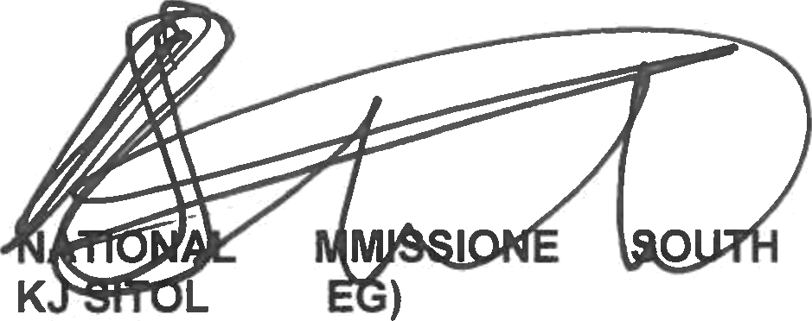
R: AFRICAN POLICE SERVICE

2

Reply to question 310 approved/not approved

MINISTER OF POLICE BH CELE, MP

Date:

