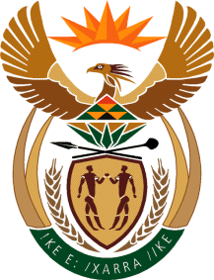

MINISTRY OF TOURISM

REPUBLIC OF SOUTH AFRICA

Private Bag X424, Pretoria, 0001, South Africa. Tel. (+27 12) 444 6780, Fax (+27 12) 444 7027

Private Bag X9154, Cape Town, 8000, South Africa. Tel. (+27 21) 469 5800, Fax: (+27 21) 465 3216

Ref: TM 2/1/1/10

NATIONAL ASSEMBLY:

QUESTION FOR WRITTEN REPLY:
Question Number: 31
Date of Publication: 11 February 2016
NA IQP Number: 1
Date of Reply: 26 February 2016

INKOSI R N CEBEKHULU (IFP) TO ASK THE MINISTER OF TOURISM:

Whether his Ministry has any frozen vacant positions; if so, (a) how many of the specified positions are vacant, (b) what are the designations of the specified positions and (c) for how long have the specified positions been vacant?
NW31E

REPLY:

The Ministry has no frozen vacant positions.

