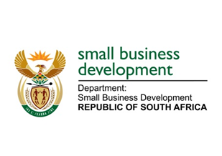
NATIONAL ASSEMBLY
QUESTION FOR WRITTEN REPLY
DUE TO PARLIAMENT: FRIDAY, 18 DECEMBER 2020

3097. Mr H C C Krüger (DA) to ask the Minister of Small Business Development:
With reference to the (a) letter, dated 31 July 2020, and (b) list of unpaid invoices sent to her by Mr H C C Krüger, what are the reasons that she has not yet responded to the specified letter? NW3927E

REPLY:
It is not normal practice for the Minister to ignore correspondence from stakeholders of the Department; and in particular from members of the Portfolio Committee on Small Business Development. The Honourable Member can be assured that the matters raised in the letter are a subject that the Minister prioritises and feels strongly about. The Honourable Member can be further assured that the Minister has raised these concerns with the Minister of Finance. However, as previously indicated in a reply to a written parliamentary question on this matter, the Office of the Chief Procurement Officer, which is situated within National Treasury, is entrusted with this responsibility and therefore the letter is requested to be re-directed to the Ministry of Finance.

Further to this, the letter was sent directly to the Minister’s inbox at a time when the Minister was in the midst of working on the department’s response to the impact of COVID-19 on small, medium and micro enterprises and co-operatives in South Africa. This, together with her numerous other commitments, does mean at times the Minister may not be able to immediately respond to the huge amount of correspondence sent directly to the Minister’s inbox, without copying the supporting officials. For this exact reason, there are a number of officials that are assigned to assist the Minister to timeously attend to correspondence and the office of the Honourable Member is requested to copy the officials in correspondence with the Minister as they were not copied the letter that was sent to the Minister in July 2020. The officials are:
- Ms Rudzani Nevhutshena: RNevhutshena@dsbd.gov.za
- Mr Akhona Jonginamba: AJonginamba@dsbd.gov.za
- Mr Moyahabo Sebe: MSebe@dsbd.gov.za

