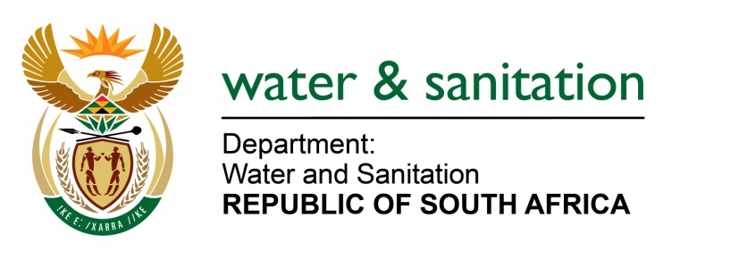

NATIONAL ASSEMBLY

FOR WRITTEN REPLY

QUESTION NO 3090

DATE OF PUBLICATION IN INTERNAL QUESTION PAPER: 21 AUGUST 2015
(INTERNAL QUESTION PAPER NO. 32)

3090. Mr I M Ollis (DA) to ask the Minister of Water and Sanitation:
(1) On what date was the most recent biomonitoring report compiled for (a) Kaap River, (b) Ngodwana River, (c) Nels River, (d) Sabie River, (e) Olifants River, (f) Limpopo River, (g) Vaal River, (h) Orange River and (i) Buffels River;
(2) What was the water quality of each specified river as reflected in the report;
(3) On what date was the sample for each specified river taken;
(4) What was the geographical location where each of the samples were taken? NW3631E
---00O00---

REPLY:

Refer to the table below for responses.

NAME OF THE RIVER | (1) RECENT BIOMONITORING | (2) WATER QUALITY | (3) SAMPLE DATE | (4) GEOGRAPHICAL LOCATION
Kaap River | done in 2013. | moderately impacted | The sample in Kaap River was taken on March/April 2012 (wet season) and August /September 2012 (dry season). | The geographical location of each samples were taken at the following sites; Holversum, Suid Kaap, Decedale; Noord Kaap, Oratava, Figtree, Lancaster and Louwscreek
Ngodwana River | done in 2013. | moderately impacted | March/April 2012 (wet season)and August /September 2012 (dry season). | Ngodwana dam
Nels River | - done in 2013 | - moderately impacted | March/April 2012 (wet season) and August /September 2012 (dry season | Rhenoesterhoek and spitzkopje.
NAME OF THE RIVER | (1) RECENT BIOMONITORING | (2) WATER QUALITY | (3) SAMPLE DATE | (4) GEOGRAPHICAL LOCATION
Sabie River, | done in 2014. | largely good with a few sites showing fair quality particularly at the headwaters which were impacted by trout fishing and forestry. | Sabie River samples were last taken in February 2013 (Wet season) and September 2013 (Dry season). | Sabie headwaters, Long Tom, above Horseshoe Falls, Sabie Hoek, Above York Saw Mill, Below Horseshoe Falls, Sabie Sewage Farm, Above Rietfontein Mine, Rietfontein Mine, DR de Wet Sabie, Frankfort Bridge, Lunsklip, Brandwag, and Aand-de-Vliet.
Olifants River, | Done in 2015 | fair state | February 2015 (Wet season) and August/ September | Klein Olifants, Kranspoortspruit, Selons, Steelpoort River, Watervals, Sterkspruit, Spekboom and Blyde.
Limpopo River | Monitoring of the Limpopo River started in 2010, in 2012 and 2013 and as it is toxic it may destroy some of aquatic life including invertebrates which indicate toxic substances in the water. | Only chemical programme is carried out with nutrients trend not posing threat. Most of the aquatic weeds are washed down the system from upstream | The sampling dates are as follows: 12-15 July 2010, 19-25 September 2011, 25June-01 July 2012, 11-14December 2013, 30- 31July2014, 02-04 2015 | Kruger National Park after Limpopo River & Luvuvhu confluence. Kruger National Park bridge on Luvuvhu River., Kruger National Park on Limpopo River, Beitbridge, Limpopo River before the weir, Downstream of Beitbridge sewage works(Zim) Limpopo River, Grobler bridge weir Limpopo River, Lephalale River on R572 Road Bridge, Mokolo River on Bridge in R572 Road, Mogalakwena River bridge on R572, Matlabas River( Bridge to Thabazimbi), Crocodile River(Bridge to Rustenburg)
Vaal River | Biomonitoring of the Upper Vaal WMA was last done on the 26th – 28stMay 2015 for Quarter 2. | Water Quality analyses were not done for the two specified WMAs because (a) No accredited laboratory services contracted and (b) No site equipment available for on-site monitoring. | No Water Quality samples taken. Macro-invertebrate sampling was done on-site for the Upper Orange WMA (26 – 28 May 2015) | 26⁰768573” 27⁰678081”; S26.87437 E28.116292; 26⁰88336” 27⁰356332”;  S26.73864 E27.592506 (for other tributary rivers,
NAME OF THE RIVER | (1) RECENT BIOMONITORING | (2) WATER QUALITY | (3) SAMPLE DATE | (4) GEOGRAPHICAL LOCATION
Orange River | Biomonitoring of the Upper Orange WMA was last done on the 9th – 11th June 2015 for Quarter 1 and the next biomonitoring of the Upper Orange WMA will be on the 14th – 18th of September 2015 | Water Quality analyses were not done for the two specified WMAs because (a) No accredited laboratory services contracted and (b) No site equipment available for on-site monitoring. | 11 of June 2015 | 29⁰573464” 24⁰07414344”; S27⁰531084” E8⁰475889”
Buffels River | The Buffels River is a non-perennial river and mostly dry throughout the year. It however flows during winter seasons only after heavy rainfall. There is therefore no active monitoring programme being implemented for this river. | N/A | N/A | N/A

---00O00---

