NATIONAL ASSEMBLY
36/1/4/1(201900044)

FOR WRITTEN REPLY QUESTION 309
DATE OF PUBLICATION IN INTERNAL QUESTION PAPER: 22 FEBRUARY 2019 (INTERNAL QUESTION PAPER NO 3-2019)

309. Mr S P Mhlongo (EFF) to ask the Minister of Police:

What number of gang-related arrests occurred in each province in each of the past two financial years?
NW328E
REPLY:

The requested information is not readily available as it needs to be obtained from the provinces and verified. A request is, thereby, made for an extension of one month, in order to provide a verified and accurate response.

Reply to question 309 recommended/

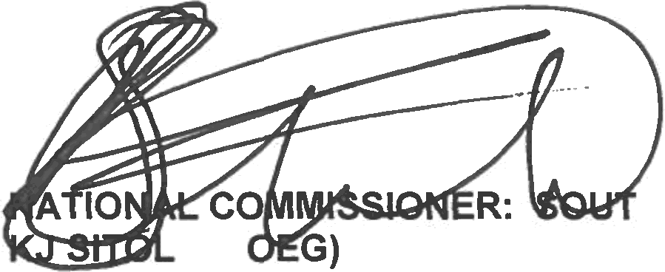
GENERAL AFRICAN POLICE SERVICE
H
E (S

Reply to question 309 approved/not approved

MINISTER OF POLICE BH CELE, MP

Date:

