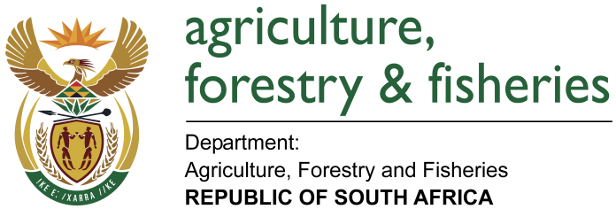
NATIONAL ASSEMBLY

WRITTEN REPLY

QUESTION 309 / NW331E

MINISTER OF AGRICULTURE, FORESTRY AND FISHERIES:

Ms P T van Damme (DA) to ask the Minister of Agriculture, Forestry and Fisheries:

QUESTION:
What amount did (a) his department and (b) each entity reporting to him spend on the promotion or celebration of the Year of O R Tambo on the (i) Africa News Network 7 channel, (ii) SA Broadcasting Corporation (aa) television channels and (bb) radio stations, (iii) national commercial radio stations and (iv) community (aa) television and (bb) radio stations since 1 January 2017? NW331E

REPLY:

- DEPARTMENT OF AGRICULTURE, FORESTRY AND FISHERIES (DAFF)

The DAFF has not sponsored promotion or celebration of the Year of O R Tambo on the (i) Africa News Network 7 channel, (ii) SA Broadcasting Corporation (aa) television channels and (bb) radio stations, (iii) national commercial radio stations and (iv) community (aa) television and (bb) radio stations since 1 January 2017?

(B) ONDERSTEPOORT BIOLOGICAL PRODUCTS OPB (SOC) LTD (OBP)

The OBP has not sponsored promotion or celebration of the Year of O R Tambo on the (i) Africa News Network 7 channel, (ii) SA Broadcasting Corporation (aa) television channels and (bb) radio stations, (iii) national commercial radio stations and (iv) community (aa) television and (bb) radio stations since 1 January 2017?

(C) NATIONAL AGRICULTURAL MARKETING COUNCIL (NAMC)
The NAMC has not sponsored promotion or celebration of the Year of O R Tambo on the (i) Africa News Network 7 channel, (ii) SA Broadcasting Corporation (aa) television channels and (bb) radio stations, (iii) national commercial radio stations and (iv) community (aa) television and (bb) radio stations since 1 January 2017?

(D) AGRICULTURAL RESEARCH COUNCIL (ARC)
The ARC has not sponsored promotion or celebration of the Year of O R Tambo on the (i) Africa News Network 7 channel, (ii) SA Broadcasting Corporation (aa) television channels and (bb) radio stations, (iii) national commercial radio stations and (iv) community (aa) television and (bb) radio stations since 1 January 2017?

(E) NCERA FARMS
The Ncera Farms has not sponsored promotion or celebration of the Year of O R Tambo on the (i) Africa News Network 7 channel, (ii) SA Broadcasting Corporation (aa) television channels and (bb) radio stations, (iii) national commercial radio stations and (iv) community (aa) television and (bb) radio stations since 1 January 2017?

(F) PERISHABLE PRODUCTS EXPORT CONTROL BOARD (PPECB)
The PPECB has not sponsored promotion or celebration of the Year of O R Tambo on the (i) Africa News Network 7 channel, (ii) SA Broadcasting Corporation (aa) television channels and (bb) radio stations, (iii) national commercial radio stations and (iv) community (aa) television and (bb) radio stations since 1 January 2017?

(G) MARINE LIVING RESOURCES FUND (MLRF)
The MLRF have not sponsored promotion or celebration of the Year of O R Tambo on the (i) Africa News Network 7 channel, (ii) SA Broadcasting Corporation (aa) television channels and (bb) radio stations, (iii) national commercial radio stations and (iv) community (aa) television and (bb) radio stations since 1 January 2017?

(H) SOUTH AFRICAN VETERINARY COUNCIL (SAVC)

The SAVC has not sponsored promotion or celebration of the Year of O R Tambo on the (i) Africa News Network 7 channel, (ii) SA Broadcasting Corporation (aa) television channels and (bb) radio stations, (iii) national commercial radio stations and (iv) community (aa) television and (bb) radio stations since 1 January 2017?

