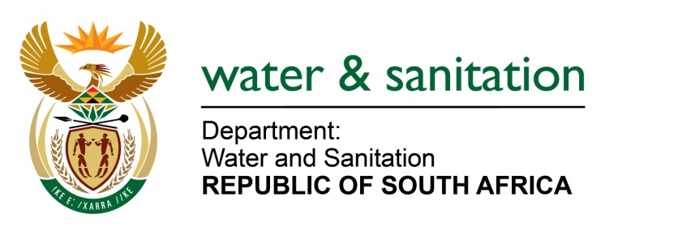

NATIONAL ASSEMBLY

FOR WRITTEN REPLY

QUESTION NO 3088

DATE OF PUBLICATION IN INTERNAL QUESTION PAPER: 21 AUGUST 2015
(INTERNAL QUESTION PAPER NO. 32)

3088. Ms T E Baker (DA) to ask the Minister of Water and Sanitation:
(1) With regard to the most recent water quality monitoring statistics, (a) which 10 South African rivers are considered the most high risk due to levels of faecal coliform and (b) on which dates were the tests conducted on the specified rivers;
(2) what is the (a) percentage risk and (b) planned remedial action for each specified river? NW3629E
---00O00---
REPLY:
- The Department of Water and Sanitation through the National Microbial Monitoring Programme (NMMP) provide the information needed to assess and manage the potential health risks to water uses related to faecal pollution of South African’s surface water resources. (a) The NMMP points are hotspots related and all the registered sites (217) are considered high risk and ranking them depend on a number of factors i.e. season, low and high rainfall period, year of assessment etc and (b) monitoring is an on-going process on a monthly/fortnightly basis.

- The potential health risk associated with the use of faecal polluted water is based on four water uses or fitness for uses; namely

- Drinking untreated water;
- Drinking after limited treatment (domestic treatment);
- Irrigation of crops that can be eaten raw; and
- Full or partial contact/recreational activities.

(2)(a) All the reports (i.e. Annual/quarterly state of water & NMMP bi-monthly) indicate that there is a high risk (100 % risk) associated with drinking untreated water directly from all NMMP hotspots sites / rivers and the risks varies (low, moderate and high) for other fitness for uses at a given period.

(2)(b) The main source of faecal pollution is discharges from poorly maintained or dysfunctional sewage treatment plants into these hotspots rivers and the Department has come up with the Green Drop System to ensure proper management of waste water treatment works or progressive improvement in their operation so as not to impact negatively on the water bodies into which they discharge (i.e. to improve the quality of the effluent). The water use upgrades licenses of other wastewater treatment plants are being assessed and there is ongoing intervention by the Department to assist the municipalities experiencing challenges. The Department is aware that there are still areas (i.e. villages & some informal settlements) experiencing challenges with regard to basic sanitation services (pit latrines/bucket system) and the possible impact and threat they can pose to water resources if not well managed. Municipalities with challenges are being assisted to get access to the Municipal Infrastructure Grant to address sanitation needs.

---00O00---

