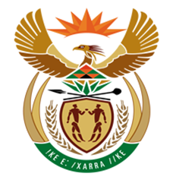

NATIONAL ASSEMBLY

QUESTION FOR WRITTEN REPLY
QUESTION NUMBER: 3084 [NW3400E]
DATE OF PUBLICATION:
3084. Mr D J Maynier (DA) to ask the Minister of Finance:
(1) Whether any person at the SA Revenue Service (a) communicated with and/or (b) invited a certain person (Nyami Booi) to participate in the press conference on the controversy surrounding a certain company (KPMG) on 18 September 2017; if not, in each case, why not; if so, what are the relevant details in each case;
(2) whether he (a) was informed and/or (b) approved (i) the press conference and (ii) the presence of the specified person at the press conference; if not, in each case, why not; if so, what are the relevant details in each case;
(3) whether he will make a statement on the matter? NW3400E

Reply:

- SARS issued a public statement about its intention to hold a press conference surrounding the SARS-KPMG Report matter on 18 September 2017 including informing the Chairpersons of the Portfolio Committee on Finance and SCOPA.

- SARS approved the press conference which was open to the public.

- A statement on the matter will not be issued.

