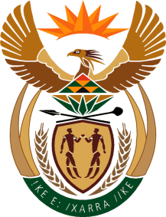

MINISTRY OF TOURISM

REPUBLIC OF SOUTH AFRICA

Private Bag X424, Pretoria, 0001, South Africa. Tel. (+27 12) 444 6780, Fax (+27 12) 444 7027

Private Bag X9154, Cape Town, 8000, South Africa. Tel. (+27 21) 469 5800, Fax: (+27 21) 465 3216

Ref: TM 2/1/1/10

NATIONAL ASSEMBLY:

QUESTION FOR WRITTEN REPLY:
Question Number: 3084
Date of Publication: 21 August 2015
NA IQP Number: 32
Date of Reply: 03 September 2015

Mr J Vos (DA) to ask the Minister of Tourism:
- How does (i) his department and (ii) entities reporting to him define red tape and (b) what (i) specific interventions and/or (ii) systems have been implemented to (aa) identify and (bb) reduce red tape in (aaa) his department and (bbb) the entities reporting to him?
NW3625E

REPLY:
(a) The department does not define red tape but certainly believes in business efficiency. With regard to business process management, the Department and SA Tourism regularly review business processes to introduce improvements where necessary.

(b)(i)(aa)(aaa) Not applicable

(b)(i)(aa) (bbb) Not applicable

(b)(ii)(bb) (aaa) Not applicable

(b)(ii)(bb)(bbb) Not applicable

