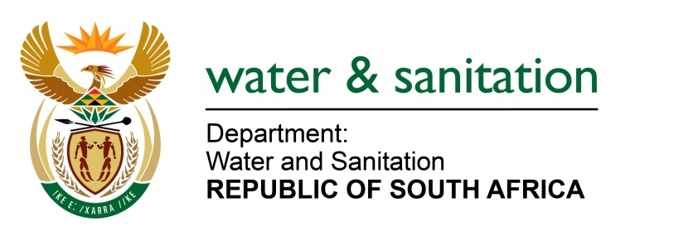

NATIONAL ASSEMBLY

FOR WRITTEN REPLY

QUESTION NO 3081

DATE OF PUBLICATION IN INTERNAL QUESTION PAPER: 16 SEPTEMBER 2022
(INTERNAL QUESTION PAPER NO. 33)

3081. Mr V Zungula (ATM) to ask the Minister of Water and Sanitation:
(1) Whether, given the long-standing water supply issues in (a) Butterworth, (b) QwaQwa and (c) Hammanskraal and how municipal officials prefer the water supply contracts in order to benefit from the supply of water to communities, he has found it necessary to take over the water affairs of municipalities that have failed to provide water to their communities; if not, what is the position in this regard; if so, what are the relevant details;
(2) by what date does he intend to intervene to provide long-term sustainable solutions to the water problems in the specified municipalities?
W2887E
---00O00---

MINISTER OF WATER AND SANITATION
- The constitutional responsibility for providing water and sanitation services rests with local government. The Department of Water and Sanitation regulates how these services are provided, monitors and supports municipalities providing water services and has a duty to intervene where national norms and standards are not met.
As indicated in the recent Green Drop and Blue Drop assessments, Municipal water services are in decline in many municipalities and government’s constitutional obligation to progressively provide safe water and a healthy environment for everyone is being compromised. In many cases, water and sanitation infrastructure is in a critical state due to inadequate investment and maintenance.
As mandated by the Constitution and other relevant legislation, the DWS has developed a Water Services Improvement Programme (WSIP) to strengthen its support and intervention at municipal level.
The aim of the programme is to support municipalities and intervene more consistently and systematically to address water and sanitation service delivery challenges. The overall aim of this initiative is to guide, initiate and lead national government support and regulatory interventions to reverse the decline in the provision of water and sanitation services in all municipalities.
Interventions being implemented by the DWS in Qwaqwa, Butterworth and Hammanskraal of the DWS
Area of intervention | Nature of interventions
Qwaqwa | - Since 2012 DWS has completed 16 projects to a total value of R524,759,353.05 in Maluti-a-Phofung LM, which includes the construction of the Sterkfontein WTW, raw water supply, bulk pipelines, reservoirs, upgrading of the Makwane WTW, drilling, and equipping of operational boreholes.  - Furthermore, a directive has been issued to Bloemwater to intervene to:  - Refurbish and Upgrade Wastewater Treatment (WWTWs) and Water Treatment Works (WTWs),  - manage and supervise Operations and Maintenance (O&M) of water and sanitation infrastructure,  - Develop a Water Services Development Plan (WSDP),  - Undertake Feasibility Studies (FS), and Implementation Readiness Studies (IRS) for future projects to ensure sustainable Water Supply and Sanitation in all areas of Maluti-a-Phofung LM.  - The DWS is actively involved in the developing and implementation of short, medium, and long-term solutions to alleviate the lack of water supply in the Maluti-A-Phofung Local Municipality.  - Three (3) projects are currently funded through grants:  - Upgrading of the Sterkfontein WTW (at 53% progress)  - Refurbishment of the Fika Patso WTW (at 24% progress)  - Construction of the reversal gravity pipeline in Qwaqwa (at 77% progress)  - Replacement of pipeline and leak repairs in Tlholong (at 88% progress)  - Drilling and equipping boreholes in Intabazwe (at 60% progress)  - Construction of the pipeline from Comet to Ha-rankopane (at 77% progress)
Butterworth | - In the case of Butterworth, the two dams supplying the town (Xilinxa and Gcuwa Wier) were dry due to drought and led to a water crisis, which was broken in January 2022. Both these dams were now full (100% as at 26 September 2022)  - A long-term solution of augmenting raw water supply to Butterworth is being prioritised and funded under the Ngqamakwe Bulk Water Supply.
Hammanskraal | - The Minister issued a notice of intention to intervene through Section 63 of Water Services Act in the City of Tshwane (CoT).  - The City did not agree to the intervention but instead requested financial support to address the water and sanitation challenges.  - The Department has informed the CoT that grant funding cannot fund water infrastructure in metropolitan municipalities. The CoT was advised to engage Human Settlement for additional Urban Settlement Development Grant (USDG) funding.  The Department had instituted legal action against the CoT for the pollution of water resources by the Rooiwaal Wastewater Treatment Works (WWTW). However, in a meeting held between the parties (DWS and CoT) on 27 September 2022, the parties agreed to have an amicable settlement on the matter where a detailed action plan will be agreed on and be a court settlement to ensure the prevention of the pollution and sustainable water supply to Hammanskraal in the medium to long term.

---00O00---

