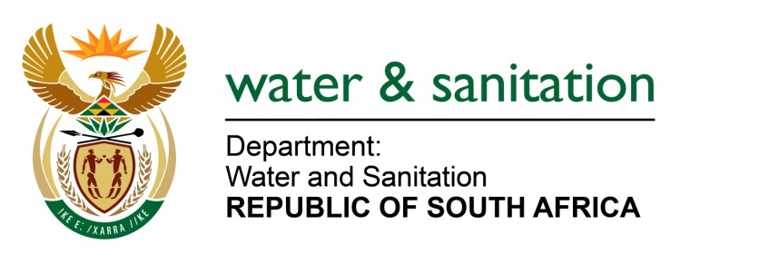

NATIONAL ASSEMBLY

FOR WRITTEN REPLY

QUESTION NO 3077

DATE OF PUBLICATION IN INTERNAL QUESTION PAPER: 9 SEPTEMBER 2022
(INTERNAL QUESTION PAPER NO. 31)

3077. Mrs L F Tito (EFF) to ask the Minister of Water and Sanitation:
What progress has been made regarding his commitment to residents in Limpopo that they would have access to adequate running water in their homes by September 2022?

NW3717E

---00O00---

MINISTER OF WATER AND SANITATION

The Nandoni-Nsami Pipeline Project consists of Construction of two (2) bulk water pipelines to provide water to Giyani and the greater Malamulele areas as well as a pump station at the Nandoni Water Treatment Works to supply water to the pipelines.

The 33.98km out of 40.50km of the Nandoni-Nsami line has been completed. There have been several delays with Glass Reinforced Plastic (GRP) pipe delivery. To date, 21.32km out of 26.58km the Nandoni-Malamulele pipeline has been laid. The project is left with chambers, pressure testing, Luvhuvu crossing and some finishing touches.

The project started on 07 March 2016 with an initial completion date of 09 November 2020. This could not be realised due to several unforeseen circumstances. The adjusted practical completion date is 14 March 2023.

The Water Service Authority (WSA), the Mopani District Municipality is also implementing additional reticulation to 55 villages that are supplied from the Giyani Water Treatment Works. Reported current progress with the reticulation project is as follows:
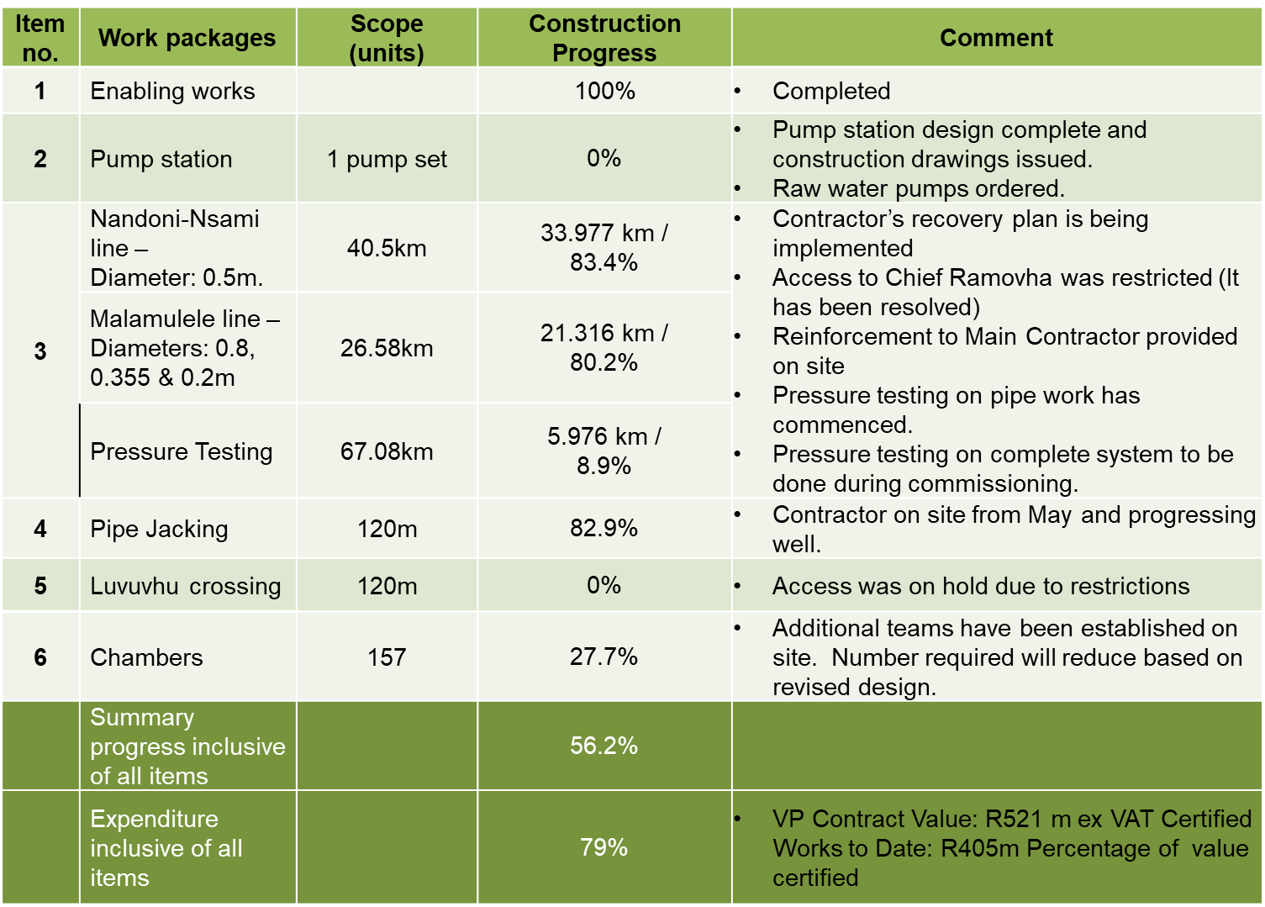

---00O00---

