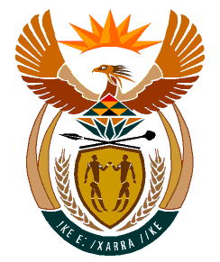

MINISTRY
HUMAN SETTLEMENTS
REPUBLIC OF SOUTH AFRICA

Private Bag X645, Pretoria, 0001. Tel: (012) 421 1309, Fax: (012) 341 8513

Private Bag X9029, Cape Town, 8000. Tel (021) 466 7603, Fax: (021) 466 3610

NATIONAL ASSEMBLY
QUESTION FOR WRITTEN
QUESTION NUMBER: PQ 3066 [NW 3706E]
DATE OF PUBLICATION: 09 SEPTEMBER 2022

PQ 3066 Ms T P Msane (EFF) to ask the Minister of Human Settlements:

a) What is the status of her department’s Alexandra Human Settlements Progress Report on the title deeds and / or transfer of restorable properties and (b) by what date will her department finalise the specified report. NW3706E

INTERIM REPLY:

- + b) The National Department has referred the matter to the Gauteng province and will provide a detailed and final reply as soon as the information is obtained.

