NATIONAL ASSEMBLY
FOR WRITTEN REPLY: QUESTION 3056

DATE OF PUBLICATION IN INTERNAL QUESTION PAPER: 26/10/2018 (INTERNAL QUESTION PAPER NO (35-2018)

3056. Dr PJ Groenewald (FF Plus) to ask the Minister of Police:

- Whether he in any way intends to amend the Firearms Control Act, Act 60 of 2000,

  - to make pro\/ision that the category to possess a firearm for self-defense should be deleted as such and;

  - in respect of the category for self-defense to own a fire-arm; if so, what are the

- reasons in each case and;

- relevant details of the proposed amendments in each case;

- whether he will make a statement on the matter? NW3420E

Reply:

- Yes, the process of amending the Firearms Control Act, Act 60 of 2000 is at an advanced stage.

The draft Bill provides for the consideration and approval process of applications for a license, infer a/la, in respect of the category for self-defense to possess a firearm, to be strengthened. This is to ensure that the proliferation of ilIega! firearms in the country are reduced.

  - See above response.

FOR WRITTEN REPLY: QUESTION 2241: DATE OF PUBLICATION IN INTERNAL QUESTION PAPER: 17 AUGUST ' 20E8: (INTERNAL QUESTION PAPER NO Z3-2018)

A statement will be released once Cabinet has approved the proposed amendments to the Bill for public comment.

ADV. DA BELL
CHIEF DIRECTOR• LEGISLAYION
DATE: g) O l§

Reply to question 3056 recommended/

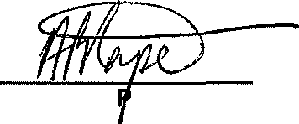

MR. AP RA EA
SECRETARY FOR POLICE SERVICE
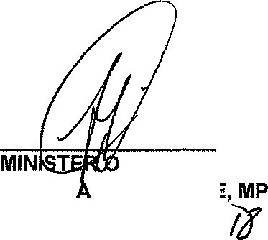
DATE:

F POLICE HONOR BL FI Ekl DATE:

2

