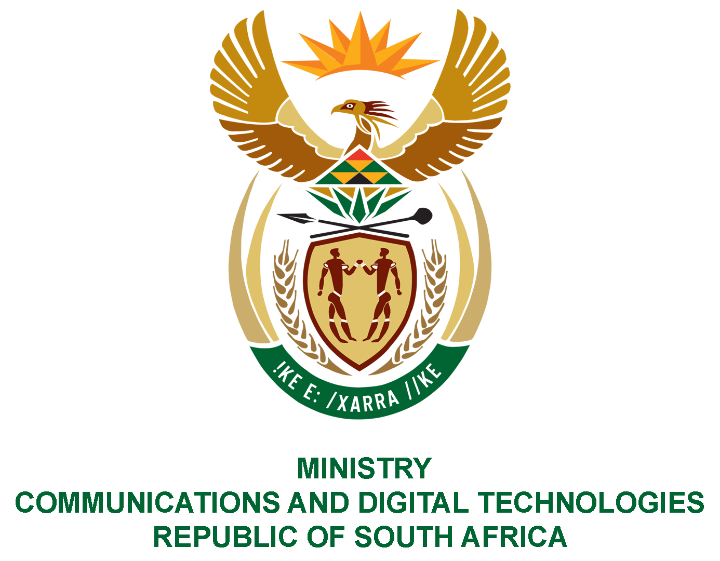

PARLIAMENT OF THE REPUBLIC OF SOUTH AFRICA

NATIONAL ASSEMBLY

WRITTEN REPLY

QUESTION: 3047
DATE OF PUBLICATION: 7 SEPTEMBER 2022
QUESTION PAPER NO: 31
Mr S Tambo (EFF) to ask the Minister of Communications and Digital Technologies:
What strategies are in place to ensure that Parliamentary, Legislatures and Council plenary sittings and committee meetings are accessible to the public through broadcasting platforms which are free to air?
NW3687E
REPLY:
I have been advised by the Department as follows:
Parliamentary sittings are broadcasted to South Africans through Commercial, Public, and Community broadcasting platforms. Secondly the parliament channel is accessible through various streaming platforms.
- Currently the public may follow sittings live on Parliament Radio and TV (DStv Channel 408), via live stream on Parliament YouTube channel and Twitter and Facebook pages. The public may subscribe to the Parliament YouTube channel to receive instant notification of live feeds, videos and streaming of the plenaries of the National Assembly and National Council of Provinces.
- The SABC’s 2020 editorial policies define events of national importance to include “the opening of Parliament, the budget speech, major Parliamentary debates, and the opening of provincial legislatures…” that it will broadcast from time to time on its national television and radio platforms.
- Parliamentary Channel is accessible through the Free-to-Air DTT platform together with other SABC television services..
- Sentech is syndicating the Parliamentary channel to over 100 community broadcasters across the country

- To further enhance above efforts, Parliament, Provincial and Local Legislatures must approve targeted funding to ensure that Parliamentary, Legislatures and Council plenary sittings and committee meetings that will ensure that they are accessible to the public through broadcasting platforms which are free to air. This is at the core of the public service mandate of the SABC and various community media broadcasters of promoting universal access and making Parliamentary, Legislatures and Council plenary sittings, committee meetings and activities more accessible to the masses or for all South Africans on a free-to-air basis. It requires deliberate and targeted funding by the three spheres to ensure that it happens daily.
- South Africa has sufficient DTT Multiplexes and streaming capacity to achieve greater accessibility, however content production and distribution costs must be covered

Authorised for submission by

MS. NONKQUBELA JORDAN-DYANI
DIRECTOR-GENERAL (ACTING)
DATE:

Recommended/not recommended

__________________________
HON. PHILLY MAPULANE, MP
DEPUTY MINISTER OF COMMUNICATIONS AND DIGITAL TECHNOLOGIES
DATE:

Approved/ not approved

________________________________
HON. KHUMBUDZO NTSHAVHENI, MP
MINISTER OF COMMUNICATIONS AND DIGITAL TECHNOLOGIES
DATE:

