NATIONAL ASSEMBLY:

QUESTION NUMBER: 3041

Adv A de W Alberts (FF Plus) to ask the Minister of Transport:
(1) Whether he can give an indication of the expected and actually realized income regarding the Gauteng e-toll system for each month from 31 December 2013 to date;
(2) what type of road user made payments through corporate and individual road users for each month during the same period respectively;
(3) what number of e-tags that are recorded have been activated and deactivated for each month during the same period;
(4) what is the total (a) amount of legal costs spent on issuing summonses to road users thus far and (b) outstanding debt to the e-toll system for each month of the specified period;
(5) whether any consideration is given to reissue summonses; if not, what is the position in this regard; if so, (a) what amount has been budgeted for this, (b) what number of persons or institutions will be sued in this regard and (c) on what date will this take place?
NW3405E

REPLY:
- Please see Table 1 below for the expected (forecast) versus realized (actual) income.

- Payments are made by an account holder who assumes responsibility to pay the account for the registered vehicles, which can be an individual, a corporate, or a combination. The person/entity that sets up the account does not complete a “field” to indicate if it is a corporate or individual user. As a result, the SANRAL toll system does not record whether a vehicle is registered (or owned) by an individual or a corporate user and the information requested cannot be directly extracted from the toll system. Should more details be required the Member of Parliament is welcome to visit SANRAL Head Office in Pretoria.

- Table 2 below provides, for each month, the number of tags that have been activated and deactivated from December 2013 to date. The table does not reflect the tags registered prior to the December 2013 date, such as the tags that were already in use on the Bakwena route. Tags are deactivated for various reasons, which include the following:
- Movement of tag to a new vehicle
- Movement of vehicles and tags between accounts, e.g. Public Entity and Key accounts
- Deregistrations, etc

Table 1: GFIP expected (forecast) versus realized (actual) income

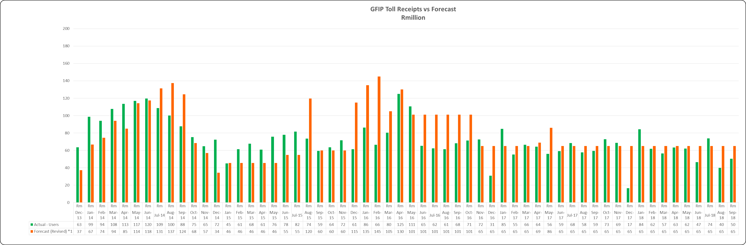

Table 2: e-Tag Activations versus Deactivations
Year | Month | Tags Activated | Tags Deactivated
2013 | December | 348382 | 22667
2014 | January | 165030 | 23480
 | February | 112086 | 18424
 | March | 87814 | 18731
 | April | 70082 | 17578
 | May | 62602 | 18419
 | June | 65643 | 19330
 | July | 51642 | 19357
 | August | 40810 | 18739
 | September | 34834 | 22980
 | October | 31604 | 17940
 | November | 25614 | 17144
 | December | 18833 | 12155
2015 | January | 24856 | 17406
 | February | 22443 | 15280
 | March | 21656 | 16827
 | April | 18924 | 15425
 | May | 22663 | 17850
 | June | 29217 | 17329
 | July | 36139 | 19312
 | August | 30274 | 21768
 | September | 30685 | 19336
 | October | 32080 | 18070
 | November | 24631 | 15287
 | December | 18624 | 12945
2016 | January | 29676 | 16615
 | February | 30536 | 16897
 | March | 31193 | 20179
 | April | 29310 | 19458
 | May | 34520 | 21343
 | June | 28130 | 19711
 | July | 32300 | 16475
 | August | 27270 | 16852
 | September | 28881 | 20350
 | October | 30733 | 16361
 | November | 26566 | 59163
 | December | 21566 | 84980
2017 | January | 30497 | 17699
 | February | 29186 | 16936
 | March | 28355 | 28654
 | April | 19699 | 17387
 | May | 24736 | 18799
 | June | 24399 | 16537
 | July | 29388 | 17478
 | August | 29138 | 17409
 | September | 26645 | 16760
 | October | 31358 | 17295
 | November | 29733 | 15409
 | December | 21410 | 12567
2018 | January | 29016 | 19675
 | February | 28005 | 16357
 | March | 21786 | 18216
 | April | 21571 | 16997
 | May | 22334 | 20042
 | June | 24091 | 14923
 | July | 29719 | 16678
 | August | 26140 | 16107
 | September | 27454 | 15749
 | October | 31005 | 16733

- (a)The Contractor (ETC) incurred R4,6m on legal fees up to August 2018.
- The Accounting Policy of SANRAL, which is in line with IFRS, determines that the impairment assessment is done on an annual basis. As such the trade receivables balance is calculated, audited and published annually. Table 3 below reflects the audited trade receivables for the requested financial years:

Financial Year | Toll debtors (R’million)
2018 | 10 840.4
2017 | 8 798.4
2016 | 6 620.1
2015 | 4 935.3
2014 | 951.3

Table 3

- SANRAL’s toll operator is not re-issuing summonses. The summonses that have already been issued will be amended to include new debt (if required) but will not require re-issuing. Therefore, we respond as follows:
- Not applicable as the re-issuing summonses is not required.
- Not applicable refer to a).
- Not applicable refer to a).

