PRIVATE BAG x 1000, PRETORIA, 0001, Tel: 082 677 2593

Memorandum from the Parliamentary Office

Minister

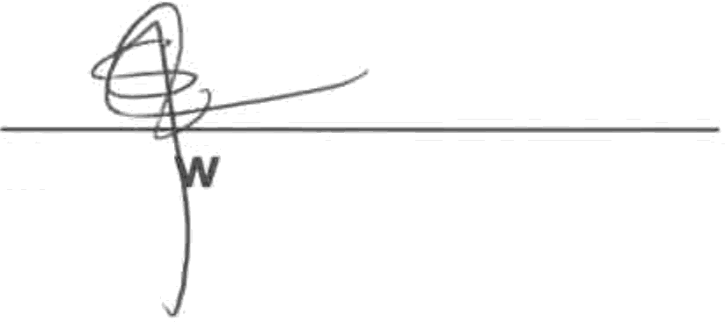
National Assembly question for written reply: 304

Mr Siz e Hlophe
Acting Parliamentary Liaison Officer Date:

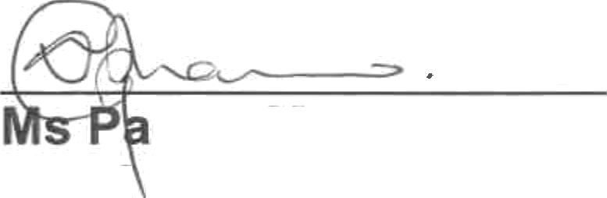
Supported /

lesa Mphamo Chief of StaR
Date: O/ \@

Recommended /
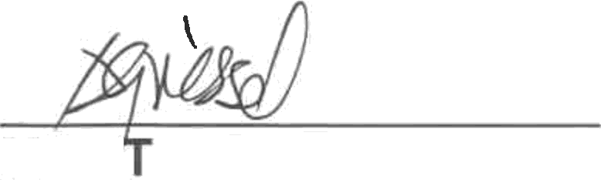

Ms A Griessel
Acting Director-General

Date: {} §//

NATIONAL ASSEMBLY QUESTION FOR WRITTEN REPLY
QUESTION NUMBER: 304
DATE OF PUBLICATION IN INTERNAL QUESTION PAPER: 22 FEBRUARY 2019
INTERNAL QUESTION PAPER NUMBER: 03 - 2019

Ms L L van der Merwe (IFP) to ask the Minister of Women in The Presidency:

Whether she has complied with the Constitutional Court ruling in which the court had found her liable for not applying an executive supervising role particularly after the SA Social Security Agency failed to comply with previous orders and instructed her to pay a portion of the legal fees; if not, why not; if so, what are the relevant details?
NW320E

Reply: As the member is aware, the legal matter referred to involved a number of legal teams representing different parties. It is through the lawyers that represented me as the then Minister of Social Development that the process will be finalised. I regularly communicate with the legal team that represents me. This far there is no correspondence on the legal fees that has been received from the other legal teams that represented the different parties.

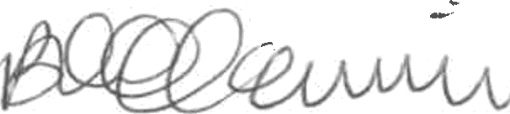

Approved by t e inis er

Date..!. 7.

