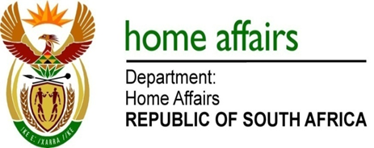

NATIONAL ASSEMBLY

QUESTION FOR WRITTEN REPLY

QUESTION NO. 304

DATE OF PUBLICATION: FRIDAY, 16 FEBRUARY 2018

INTERNAL QUESTION PAPER 2 OF 2018

304. Mr M Waters (DA) to ask the Minister of Home Affairs:

Does she intend to amend legislation to allow South Africans living abroad to produce only one official document when voting; if not, (a) why not and (b) is it not discriminatory against those South Africans living abroad to have to provide two official documents when South Africans voting at home only have to produce an identity document; if so, when will these amendments be tabled? NW326E
REPLY:

Ahead of the 2019 national and provincial elections, the intention of the Electoral Commission is to amend section 11(1) of the Election Regulations, 2004, such that South African citizens who intend to apply to vote abroad will not be required to produce a passport, but will be required to produce an identity document or smart identity card indicating citizenship of the Republic of South Africa. The proposal to amend electoral legislation falls within the statutory jurisdiction of the Electoral Commission.

