Private Bag X893, Pretoria, 0001, Tel (012) 312 5555, Fax (012) 323 5618
Private Bag X9192, Cape Town, 8000, Tel (021) 469 5150, Fax: (021) 465 7956
Memorandum from the Parliamentary Office
NATIONAL ASSEMBLY
FOR WRITTEN REPLY
QUESTION 3036
DATE OF PUBLICATION OF INTERNAL QUESTION PAPER: 26/10/2018
(INTERNAL QUESTION PAPER NO 35 OF 2018)
Ms N Nolutshungu (EFF) to ask the Minister of Higher Education and Training:
What (a) will be the capacity of each faculty at each institution of higher learning in 2019 and (b) number of first year students will each specified institution of higher learning be able to accept in 2019?
NW3276E
REPLY:
- Universities have a variety of ways in which they name their faculties, and therefore, the programmes offered by faculties across institutions vary considerably. The enrolment plan for each university is not developed per faculty, but rather for the institution as a whole. It is therefore not possible to indicate the capacity of each faculty at each institution. However, it is possible to provide the planned overall enrolments per field of study at each university.
Table 1 below shows the approved enrolment planning targets for each university by major fields of study in Science, Engineering and Technology; Business and Commerce; Education and Other Humanities, for 2019.
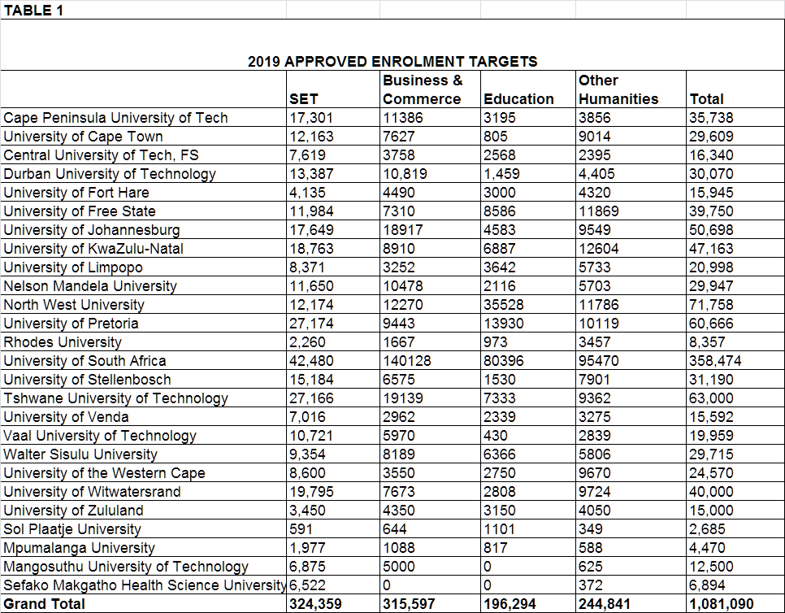

- The approved number of first-time entering students across all fields of study that each university will be able to accept in the 2019 academic year, is indicated in table 2 below.
