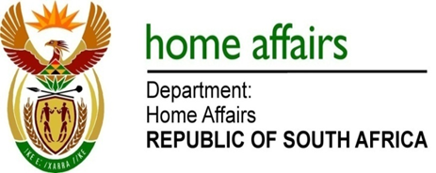

NATIONAL ASSEMBLY

QUESTION FOR WRITTEN REPLY

QUESTION NO. 303

DATE OF PUBLICATION: FRIDAY, 16 FEBRUARY 2018

INTERNAL QUESTION PAPER 2 OF 2018

303. Mr M Waters (DA) to ask the Minister of Home Affairs:

With reference to the reply to question 2207 on 17 August 2017, what progress has been made with regard to the process that will give naturalised citizens the opportunity to apply for new Smart ID Cards? NW325E
REPLY:

As indicated previously, the Department continues to rollout the issuance of smart ID Cards in a phased-in approach. The process of expanding the Live Capture footprint and the verification process of the records for naturalised citizens are ongoing as are the system upgrades which will make provision for this category of applicants.

Upon determination of adequate footprint and system status readiness, the Minister will make an announcement which will give naturalised citizens the opportunity to apply for Smart ID Cards

