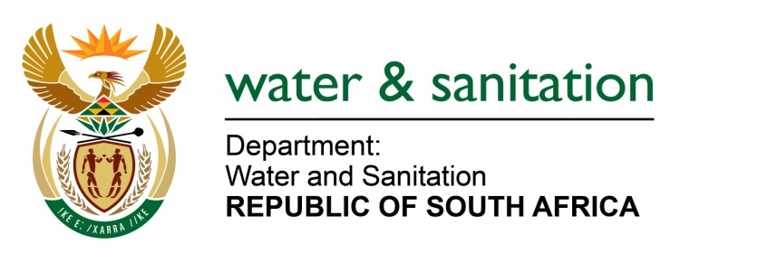

NATIONAL ASSEMBLY

FOR WRITTEN REPLY

QUESTION NO 3025

DATE OF PUBLICATION IN INTERNAL QUESTION PAPER: 6OCTOBER 2017
(INTERNAL QUESTION PAPER NO. 34)
3025. Mrs A M Dreyer (DA) to ask the Minister of Water and Sanitation:
(1) What is the (a) total amount that was paid out in bonuses to employees in her department and (b) detailed breakdown of the bonus that was paid out to each employee in each salary level in the 2016-17 financial year;
(2) what is the (a) total estimated amount that will be paid out in bonuses to employees in her department and (b) detailed breakdown of the bonus that will be paid out to each employee in each salary level in the 2017-18 financial year? NW3344E

---00O00---
REPLY: 3025 1

1(a) 1.5% of the total provision for salaries is allocated towards performance reviews. This regulation is provided for by the Department of Public Service and Administration. My Department has complied with the regulation and a total of
1 961 employees qualified for performance bonuses.

- See table below for a detailed breakdown of payout to officials that qualified in the 2016/17 financial year.

SALARY LEVEL | TOTAL NUMBER OF OFFICIALS | AMOUNT PAID
2 | 191 | R 1 006 931.58
3 | 166 | R 1 109 388.28
4 | 67 | R 462 316.22
5 | 159 | R 1 530 318.61
6 | 252 | R 2 742 637.89
7 | 313 | R 4 238 651.31
8 | 238 | R 3 776 621.45
9 | 114 | R 2 138 783.22
10 | 171 | R 4 054 542.86
11 | 107 | R 2 807 539.15
12 | 181 | R 6 501 801.50
13 | 1 | R 58 092.84
14 | 1 | R69 069.60
Grand Total | 1961 | R30 496 693

(2) Performance rewards for the 2017-18 financial year have not been finalized, as the financial year ends in March 2018.

---00O00---

