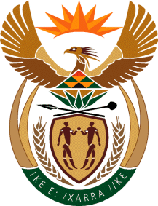
MINISTRY
SPORT AND RECREATION
REPUBLIC OF SOUTH AFRICA

Department of Sport and Recreation l Private Bag X896 l PRETORIA l 0001 l Regent Place l 66 Queen Street l Pretoria l 0001 l +27 (0)12 304 5158 l Fax: +27 (0)12 323 8426
Private Bag X9149 l Cape Town l 8000 l 2nd Floor Parliament Building l 120 Plain Street l CAPE TOWN l Tel: +27 21 469 5705 l Fax: +27 21 465 4402
www.srsa.gov.za
_____________________________________________________________________

NATIONAL ASSEMBLY

WRITTEN REPLY

QUESTION PAPER: No. 34 of 06 OCTOBER 2017

DATE OF REPLY: 01 DECEMBER 2017

3019. Mr H B Groenewald (DA) asked the Minister of Sport and Recreation:
(1) What is the (a) total amount that was paid out in bonuses to employees in his department and (b) detailed breakdown of the bonus that was paid out to each employee in each salary level in the 2016-17 financial year;

(2) what is the (a) total estimated amount that will be paid out in bonuses to employees in his department and (b) detailed breakdown of the bonus that will be paid out to each employee in each salary level in the 2017-18 financial year? NW3338E
______________________________________________________________________

The Minister of Sport and Recreation

REPLY:

(1)(a) No payments have been made as yet.

(1)(b) Not applicable.

(2)(a) and (b) The Department of Sport and Recreation will not be in a position to provide estimate amounts that will be paid at this stage, but will process payments within the 1% threshhold of the Department’s compensation budget for the 2017/ 2018 financial year.
*********************************

