FOR WRITTEN REPLY

QUESTION 3017

NATIONAL ASSEMBLY
36/1/4/1(201800292)

DATE OF PUBLICATION IN INTERNAL QUESTION PAPER: 19 OCTOBER 2018 (INTERNAL QUESTION PAPER NO 33-2018)

3017. Mr P van Dalen (DA) to ask the Minister of Police:

- What number of (a) murders were reported at the Germiston Police Station in the (i) 2015-16, (ii) 2016-17 and (iii) 2017-18 financial years and (b) of the specified murders resulted in a successful conviction;

- what number of (a) women and (b) children were murder victims?

REPLY:

NW3331E

(1)(a)(i)(ii)(iii) The number of murders, which were reported at the Germiston Police Station, is as follows:
2015/2016 | 2016/2017 | 2017/2018
48 | 45 | 55
(1)(b) The number of murders, which resulted in successful convictions, is as

2015/2016 |  | 2016/2017 |  | 2017/2 18
CAS  Number | Conviction | CAS  Number | Conviction | CAS  Number | Conviction
648/05/2015 | 15 years  imprisonmen t | 650/05/2016 | 3 years  imprisonmen t | None | Not applicable
571/06/2015 | 3 years  imprisonmen t | 160/08/2016 | Life  imprisonmen t
454/01/2016 | 15 years  imprisonmen  t | 753/12/2016 | 15 years  imprisonmen  t

(2)(a)(b) The number of women and children, who were murder victims, is as follows:
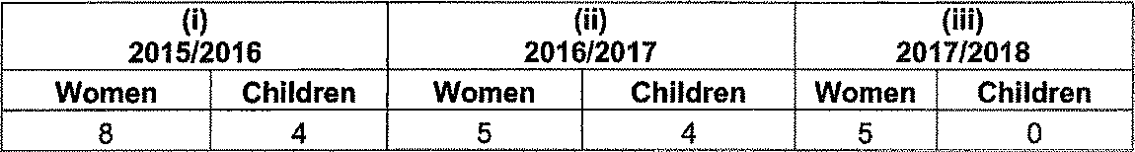
2015/2016
2016/2017
2017/2018
Women Children Women Children Women Children
8 4 5 4 5 0

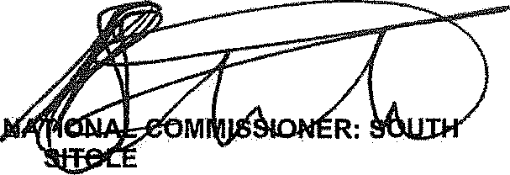
Reply to question 3017 recommended

KJ (SOEG)
Date: ytI18 *»* › ›
Reply to question 3017 approved/n

MINISTER OF POLICE BH CELE, MP

Date: [[
GENERAL AFRICAN POLICE SERVICE

