36/1/4/1(201800293)
NATIONAL ASSEMBLY

FOR WRITTEN REPLY
QUESTION 3016
DATE OF PUBLICATION IN INTERNAL QUESTION PAPER: 19 OCTOBER 2018 (INTERNAL QUESTION PAPER NO 33-2018)

3016. Mrs A M Dreyer (DA) to ask the Minister of Police:

- What number of(a) murders were reported at the Primrose Police Station in the
  - 2015-16, (ii) 2016-17 and (iii) 2017-18 financial years and (b) of the specified murders resulted in a successful conviction;

- what number of (a) women and (b) children were murder victims?

REPLY:

NW3330E

(1)(a)(i)(ii)(iii) The number of murders, which were reported at the Primrose Police Station, is as follows:
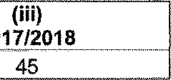
(i)

(1)(b) The number of murders, which resulted in successful con\fictions, is as follows:
2015/2016
2016/2017
2017/2018
CAS
Number
306/08/201

4
Conviction
10 years imprisonmen t
10 years imprisonmen t
8 years
imprisonmen
CAS
CAS
Number
259/07/2012
Conviction
15 years imprisonmen I
Number
271/07/2016
Conviction
10 years imprisonmen
156/09/201
159/09/2016
4 years imprisonmen

447/02/201
311/10/2015
10 years imprisonmen
71/03/2015
13 years imprisonmen t
332/01/2016
224/03/2015
2 suspects,
each 10 years imprisonmen t
18 years "" imprisonmen
..!-.-.
325/01/2014 18 years

imprisonmen
96/02/2016
20 years imprisonmen

(2)(a)(b) The number of women and children, who were murder Victims, is as follows:
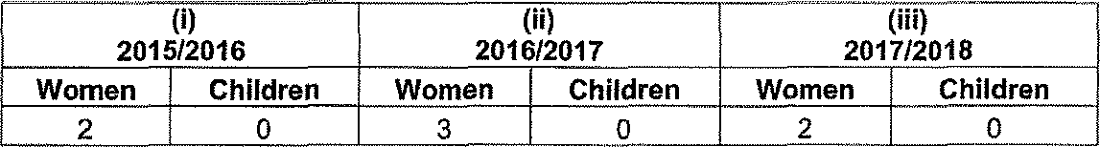
2015/2016
2016/2017
2017/2018
Women Children Women Children Women Children
2 0 3 0 2 0

Reply to question 3016 recommended/

TI
LE (
GENERAL UTH AFRICAN POLICE SERVICE

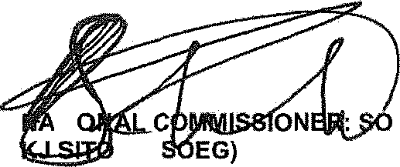
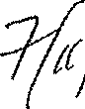
Date: 18 11 t
Reply to question 3016 approved/
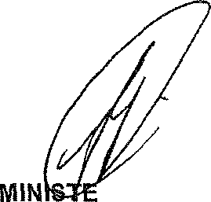

R OF POLICE

BH CELE, MP

