36/1/4/1(201800294)
NATIONAL ASSEMBLY

FOR WRITTEN REPLY QUESTION 3015
DATE OF PUBLICATION IN INTERNAL QUESTION PAPER: 19 OCTOBER 2018
fINTERNAL auEsTiON PAPER NO 33-2016)

3015. Mrs A M Dreyer (DA) to ask the Minister of Police:

What number of (a) murders were reported at the Bedfordview Police Station in the (i) 2015-16, (ii) 2016-17 and (iii) 2017-18 financial years and (b) the specified murders resulted in a successful conviction;

- what number of (a) women and (b) children were murder victims?

REPLY:

NW3329E

(1)(a)(i)(ii)(iii) The number of murders, which were reported at the Bedfordview Police Station, is as follows:
20....1...5..../.2....0...1....6..................................... ...........................2...0....1...6.../..2...0...1...7..............
7 7
2017/2018
1

(1)(b) The number of murders, which resulted in successful convictions, is as follows:

2015/2016 |  | 2016/2017 |  | 2017/2018
CAS Number | Conviction | CAS  Number | Conviction | CAS  Number
205/11/2015 | 10 years imprisonment | None | Not applicable | None | Not applicable
91/01/2016 | 18 years imprisonment

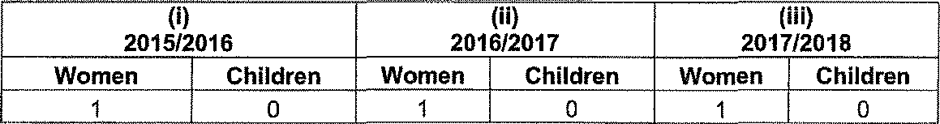
(2)(a)(b) The number of women and children, who were murder victims, is as follows:

2015/2016  Women Children |  | 2016/2017  Women Children | 2017/2018  Women Children
1 | 0 | 0 | 1 0

Reply to question 3015 recommended/

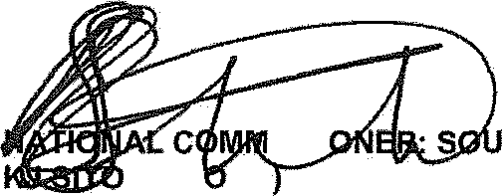
GENERAL TH AFRICAN POLICE SERVICE

ISSI
LE (S EG

Date: ) i8-1)’ j§
Reply to question 3015 approved/

MINIS F POLICE BH CEO, M

Date:

