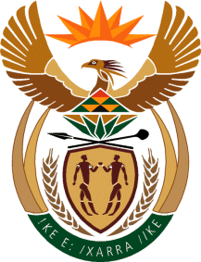

MINISTRY OF TOURISM
REPUBLIC OF SOUTH AFRICA

Private Bag X424, Pretoria, 0001, South Africa. Tel. (+27 12) 444 6780, Fax (+27 12) 444 7027
Private Bag X9154, Cape Town, 8000, South Africa. Tel. (+27 21) 469 5800, Fax: (+27 21) 465 3216

NATIONAL ASSEMBLY:

QUESTION FOR WRITTEN REPLY:
Question Number: 3014
Date of Publication: 4 December2020
NA IQP Number: 51
Date of reply: 05 November 2020

Mr M S F de Freitas (DA) to ask the Minister of Tourism:
With reference to the tourism offices in the nine provinces, (a) what offices are established in each province, (b) where is each office physically located in each case, (c) what new offices have been established in the past three financial years to date, (d) how have these offices been affected by the lockdown to curb the spread of the coronavirus, (e) what are the functions of each office, (f) how are the specified functions (i) monitored and (ii) measured and (g) what are the monthly costs of each office? NW3842E

REPLY:
The Department of Tourism does not have tourismoffices in the nine provinces of South Africa.
- - (g) Not applicable.

