NATIONAL ASSEMBLY
36/1/4/1(201800297)

FOR WRITTEN REPLY QUESTION 3014
DATE OF PUBLICATION IN INTERNAL QUESTION PAPER: 19 OCTOBER 2018 (INTERNAL auEsTiON PAPER NO 33-2018›

3014. Mrs A M Dreyer (DA) to ask the Minister of Police:

- What number of (a) murders were reported at the Elsburg Police Station in the
  - 2015-16, (ii) 2016-17 and (iii) 2017-18 financial years and (b) the specified murders resulted in a successful conviction;
- what number of(a) women and (b) children were murder victims?
NW3328E
REPLY:

(1)(a)(i)(ii)(iii) The number of murders, which were reported at the Elsburg Police Station, is as follows:
2015/2016 | 2016/2017 | 2017/2018
8 | 18 | 12

(1)(b) The number of murders, which resulted in successful convictions, is as follows:

2015/2016 |  | 2016/2017 |  | 2017/2018
CAS Number | Conviction | CAS  Number | Conviction | CAS  Number | Conviction
281/09/2015 | Three Years  Imprisonment | None | Not applicable | None | Not applicable
215/12/2015 | Life  Imprisonment
(2)(a)(b) The number of women and children, who were murder victims, is as follows:
2015/2016 |  | 2016/2017 |  | 2017/2018
Women | Children | Women | Children | Women | Children
1 | 0 | 0 | 0 | 1 | 0

Reply to question 3014 recommended d

2

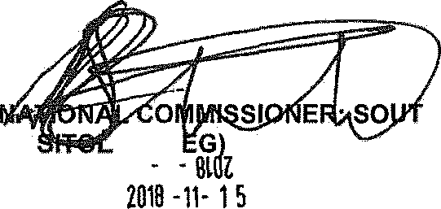
GENERAL
H
KJ
E (SO
$ ( It
Date:
AFRICAN POLICE SERVICE

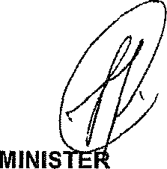
Reply to question 3014 approved/

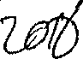
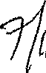
OF POLICE BH CELE, MP

