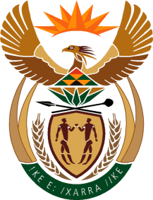

MINISTRY OF TOURISM
REPUBLIC OF SOUTH AFRICA

Private Bag X424, Pretoria, 0001, South Africa. Tel. (+27 12) 444 6780, Fax (+27 12) 444 7027
Private Bag X9154, Cape Town, 8000, South Africa. Tel. (+27 21) 469 5800, Fax: (+27 21) 465 3216

NATIONAL ASSEMBLY:

QUESTION FOR WRITTEN REPLY:
Question Number: 3013
Date of Publication: 4 December 2020
NA IQP Number: 51
Date of reply: 16 December 2020

Mr M S F de Freitas (DA) to ask the Minister of Tourism:
(a) What (i) criteria and (ii) scientific data are used to create the red list of high-risk countries from which persons are permitted to travel to the Republic, (b) on what date is the list updated and (c) what criteria determines that the list needs to be updated? NW3841E
REPLY:
The Department of Tourism does not handle scientific data dealing with the determination of red list of high-risk countries. The matter falls within the mandate of the Department of Health.
(a)– (c) Not applicable

