MINISTRY FOR COOPERATIVE GOVERNANCE AND TRADITIONAL AFFAIRS
REPUBLIC OF SOUTH AFRICA

NATIONAL ASSEMBLY
QUESTIONS FOR WRITTEN REPLY
QUESTION NUMBER 2018/3011
DATE OF PUBLICATION: 19 OCTOBER 2018

3011. Mr M Waters (DA) to ask the Minister of Cooperative Governance and Traditional Affairs:
  - Whether he will call for an enquiry into the alleged incompetence of the Edenvale Fire Department while responding to a fire at a factory, including but not limited to (a) why firefighters were waiting outside the premises while the fire raged and spread to other factories, (b) the reasons why one fire engine did not have any water in its tank while it took excessive time for the crew of the second fire engine to find a fire hydrant, (c) why it took the fire crew 20 minutes to set up their equipment once they arrived on the premises and (d) why only one hose was used to extinguish the fire; if not, why not;

  - Whether any norms and standards were transgressed while responding to the fire; if so, which norms and standards? NW3325E

REPLY:

The information requested by the Honourable Member was obtained from the National Disaster Management Centre (NDMC) in the City of Ekurhuleni (CoE). The response to the question and its sub-components by the CoE is outlined below.

a) Why firefighters were waiting outside the premises while the fire raged and spread to other factories?

On arrival, Firefighters conducted a scene size-up and realised that the gates were locked hence forcible entry tools had to be gathered. Prior to utilizing forcible entry tools, Firefighters further realised that the perimeter fence was electrified and the current was still alive. In terms of section 8 of the Fire Brigade Services Act, 1987 (Act No 99 of 1987) (FBSA), a member of a service of a controlling authority, including a Chief Fire Officer, may, whenever he/she regards it necessary or expedient to perform his/her functions (i) Close any road or street and (ii) Enter or break and enter any premises and (iii) Damage, destroy or pull down any property. Thus, while Firefighters are empowered to forcible enter any premises, in this case, they had to engage the Security Officer / Guard to alert an Electrician to come and isolate the power supply. It is important to note that in many incidents of this nature globally, many lives of Firefighters are lost due to inadequate consideration of safety factors such as dealing with electrified perimeter fences. Firefighters are trained to save lives but this should be done in a manner that does not comprise their safety. Thus, Firefighters had to wait for the safety signal from an Electrician before firefighting operations could start safely.

b) The reasons why one fire engine did not have any water in its tank while it took excessive time for the crew of the second fire engine to find a fire hydrant?

It is important to note that upon arrival, a defensive attack mode was initiated immediately with the water from the engine tank. No industrial or rescue fire engines respond to the scene without water. The standard operational procedure is that, for each shift change, the on-coming shift checks the resources for operational readiness. Fire engines and water tanks are regularly topped up to their maximum. Fire engines differ in sizes as per the manufacturing specifications. Typically, they range from about 800 litres capacity to about 15 000 litres depending on the individual size. The rescue tenders and major industrial fire pumpers that were mainly used on the day, ranges from 2 200 litres and 3 500 litres respectively and those are the primary responding pumps to the scene. The scene was complemented by backup pumps/fire engines/ water tankers from the surrounding stations. As per local operational preparedness and standards, Bedfordview and Primrose fire stations, operating in the same district as Edenvale fire station, both arrived on the scene with major pumpers to re-enforce firefighters from numbers and equipment`s perspective.

Water tank capacity of the major industrial pumper as per American National Fire Protection Association (NFPA) standards, which are globally accepted standards utilised by Fire Services, dictate that it (industrial pumper) (Pictures 1 and 3) should carry about 3500 litres of water in transit. Discharge pressure of about eight to ten (8-10) bars through a single orifice of 64 mm diameter means that the tanks will be empty in less than five minutes and if two discharge hoses are connected, it means that the tank will be empty in less than three minutes. This is the reason why members of the public think that fire engines always arrive on scene with empty tanks, which is not the case. The municipality, for illustrative purposes, has attached pictures of the industrial fire pumper and the hydraulic platform that were utilised in this incident as outlined below:

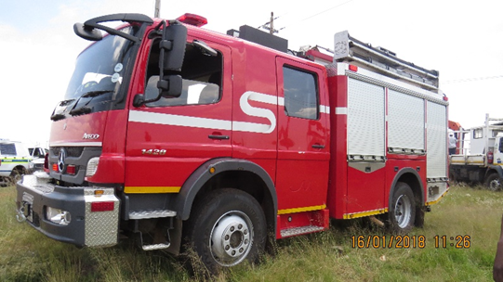
Picture 1: Industrial Fire Pumper

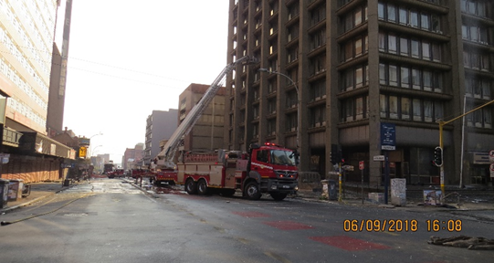
Picture 2: Water Tanker and Hydraulic Platform

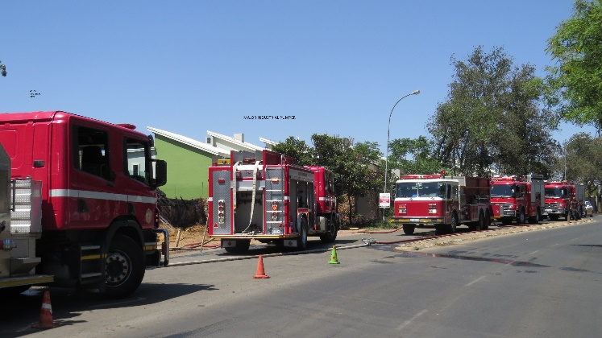
Picture 3: Industrial Fire Pumper

In line with the globally accepted standards and practices, the municipality also deployed specialised vehicle in the form of a Hydraulic Platform Fire Engine (Picture 2) to be on standby at the scene for utilisation if required. It is important to note that although the hydraulic platform does not carry water as per its specifications, its main purpose is to pump water to different heights supplied via other fire engines and to rescue the trapped occupants in high rise buildings. Water should be relayed either from the fire hydrant or from the water tankers through its inlets valves and boosted via the water channel running under the ladder to the required height. This was the same hydraulic platform that was utilised in the Johannesburg Bank of Lisbon structural fire on 05 September 2018. In the case of Edenvale, this appliance was not utilised as the building which was on fire was not a high-rise building. It was dispatched for safety reasons in case its use would be required.

With regard to why it took excessive time for the second fire engine to find a fire hydrant, it is important to note that the first arriving pump from Edenvale Fire station, identified the fire hydrant and immediately connected the water supply hoses to the fire engine. The street fire hydrant was fully functional (Picture 4). The secondary back-up pumps that arrived on the scene parked strategically on the opposite side and managed to identify the fire hydrant inside the premises after access was gained through the gates but unfortunately that hydrant was non-functional (Picture 5). The firefighters opted for another street fire hydrant which was a few metres away from the fire engine. Fortunately, water pressure from that hydrant was excellent and they managed to couple several hoses from it to the fire engine for sustainable supply.
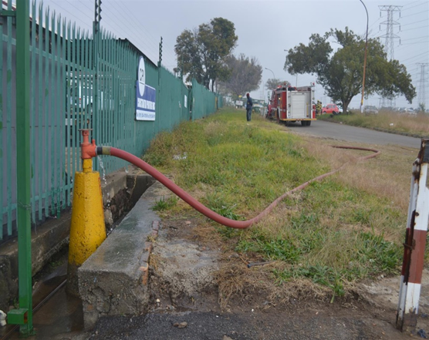
Picture 4: Functional street fire hydrant used on the day

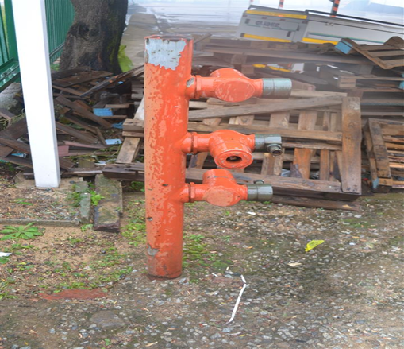
Picture 5: Internal Non-functional Fire Hydrant

It is imperative for the owners to ensure the full functionality of installed fire-fighting equipment including fire hydrants in their properties which must be checked by a qualified service provider annually.

c) Why it took the fire crew 20 minutes to set up their equipment once they arrived on the premises

As alluded to the above, the first arriving pump from Edenvale Fire station identified a functional street fire hydrant and immediately connected it to the fire engine. The secondary back-up pumps that arrived on the scene, parked strategically on the opposite side and managed to identify the fire hydrant inside the premises after the gates were opened but unfortunately this hydrant was not functional. This means that the attack plan had to be changed as the secondary fire hydrant was identified down the street, a few metres away from the secondary fire engine. Accordingly, four 30 metre hoses had to be run-out to facilitate the objective. Thus, the non-functional fire hydrant in the premises coupled with the electrified perimeter fence which had to be isolated by an Electrician as outlined above delayed firefighting efforts.

(d) Why only one hose was used to extinguish the fire; if not, why not?

The first arriving pump, established an attack line as per operational standards for exposure protection and subsequently direct offensive firefighting is put in place to extinguish the blaze. Operational sectorisation is imperative in terms of pumps placement. Fire-fighting from all four cardinal points was initiated as the situation dictated. Fire engines were strategically placed to be able to protect the exposed buildings and to extinguish the structures that were already burning. Major industrial pumpers and rescue pumpers can directly discharge water through four orifices (discharges). However, that does not include the multiple dividing equipment used. In terms of the scene expansion, more resources arrived on the scene and more attack lines (fire hoses) were used from different fire engines.

1.2 Whether any norms and standards were transgressed while responding to the fire; if so, which norms and standards?

No norms and standards were transgressed on scene from the operational point of view. Standard Operating Procedures were followed for command and control of the incident. Thus, there is no need for the Minister to institute an enquiry regarding the response of the municipality to this fire incident.

- BACKGROUND INFORMATION

  - The importance of firefighter safety on the line of duty

The NDMC is concerned about the safety of firefighters especially during firefighting operations. The term line of duty refers to (a) Being at the scene of an alarm, whether a fire or non-fire incident, (b) Responding to or returning from an alarm, (c) Participating in other fire services duties such as training, maintenance, public education, inspection, investigation, and (d) Being on call or stand-by for assignment at a location other than at the firefighter’s home or place of business. The death of three firefighters in the Bank of Lisbon fire in central Johannesburg highlighted the occupational dangers faced by firefighters during firefighting operations. It is important to note that, in line with global standards, firefighters can and must only fight fires if it is safe to do so. Thus, the safety of firefighters is primary and cannot be compromised under any circumstances. The dangers posed by the electrified perimeter fence to the safety of firefighters cannot be taken for granted and in this regard, the operational strategies deployed by the CoE were adequate and necessary to safeguard the safety of firefighters.

  - National norms and standards

With regard to national norms and standards for the provision of fire services, the South African National Standard (SANS) 10090: Community Protection Against Fire is the primary barometer utilised by most municipalities to measure the performance of fire services. The purpose of this standard is to provide advice on the measures that should be taken to ensure that fire services are efficient. It includes a schedule against which the performance potential of each aspect, as well as of the whole, of a fire service can be judged. A fire-risk rating based on this schedule will indicate the extent to which loss of life and property can be avoided in any particular given area. The SANS 10090 is based on the premise that successful control and extinguishing of fires depend on sufficient appliances responding with adequate manpower and arriving within a reasonable time. It is important to highlight that although most fire services comply with the requirements of this standard, it only becomes applicable once a municipality adopts it as its service delivery standard. The CoE has adopted this standard as its service delivery standard. From the report/ response received from CoE, it is clear that the City complied with the standard in its deployment of firefighters and resources to this incident. In terms of this standard, the weight of response to fires is as outlined below:

Weight of response in terms of SANS 10090: Community protection against fire
1 | 2 | 3 | 4
Risk Category | Minimum number of pumping units | Minimum manning level per appliance | Minimum pumping capacity of each unit (L/min)
A (Central business districts and extensive commercial and industrial areas normally found in cities and large towns (areas where the risk to life and property due to fire occurrence and spread is likely to be high). | 2 | 5 | 3850
B (Limited central business districts, smaller commercial or industrial areas normally associated with small towns and decentralized areas of cities and large towns (areas where the risk to life and property due to fire occurrence and spread is likely to be moderate). | 2 | 4 | 3850
C (Residential areas of conventional construction). | 1 | 4 | 2 250
D (Rural areas of limited buildings and remote from urban areas).  D1 (Houses > 30 m apart)  D2 (Houses 10,1 m – 30 m apart)  D3 (Houses 3 m – 10 m apart)  D4 (Houses < 3 m apart) | 1 | 4 | 2 250
E (Special risk areas. Individual areas requiring a pre-determined attendance over and above the predominant risk category in an area. Includes large shopping/entertainment centres, informal settlements, harbours, hospitals, prisons, large airport buildings and petrochemical plants). | As determined by individual risk assessment
Note: Arrangements for vehicle fires, grass/bush and special services and the need for specialist vehicles such as aerial appliances and water carriers will be determined by local conditions.

