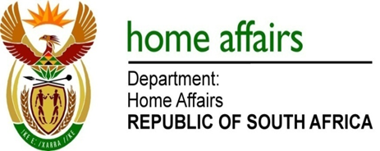

NATIONAL ASSEMBLY

QUESTION FOR WRITTEN REPLY

QUESTION NO. 3004

DATE OF PUBLICATION: FRIDAY, 6 OCTOBER 2017

INTERNAL QUESTION PAPER 34 OF 2017

3004. Ms S V Kalyan (DA) to ask the Minister of Home Affairs:

- What is the (a) total amount that was paid out in bonuses to employees in her department and (b) detailed breakdown of the bonus that was paid out to each employee in each salary level in the 2016-17 financial year;

(2) what is the (a) total estimated amount that will be paid out in bonuses to employees in her department and (b) detailed breakdown of the bonus that will be paid out to each employee in each salary level in the 2017-18 financial year?

NW3323E
REPLY:

(1)(a-b) For the financial year 2016/2017 the Department of Home Affairs has not yet paid performance bonuses and pay progressions.

(2)(a-b) The total estimated amount that will be paid out in bonuses to employees in the 2017/18 financial year can only be determined after the conclusion of performance assessments.

