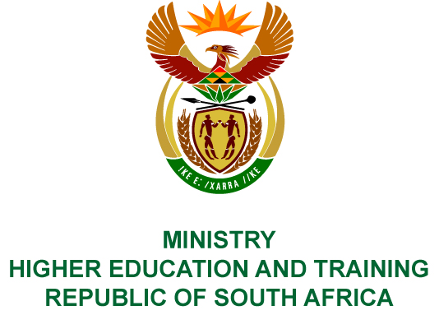
Private Bag X893, Pretoria, 0001, Tel (012) 312 5555, Fax (012) 323 5618
Private Bag X9192, Cape Town, 8000, Tel (021) 469 5150, Fax: (021) 465 7956
Memorandum from the Parliamentary Office
NATIONAL ASSEMBLY
FOR WRITTEN REPLY
QUESTION 30
DATE OF PUBLICATION OF INTERNAL QUESTION PAPER: 08/02/2018

(INTERNAL QUESTION PAPER NO 1 OF 2018)
Mr D America (DA) to ask the Minister of Higher Education and Training:
(1) Whether she has been informed of the investigation undertaken by the Independent Police Investigative Directorate and the Inspector General of Intelligence that seeks to establish whether funds from the secret service account were used to fund aspects of the #FeesMustFall protests on higher education campuses; if not, what is the position in this regard; if so, what are the relevant details;
(2) has she engaged with (a) the Minister of State Security and/or (b) the Minister of Police on this matter; if not, in each case, why not; if so, what was the nature of the engagement in each case;
(3) has her department commission any investigation into the alleged involvement of any members of the Cabinet in fuelling some #FeesMustFall protests; if not, why not; if so, what are the relevant details?
NW34E

REPLY:
- The Minister is not aware of any investigation being undertaken by the Independent Police Investigative Directorate and Inspector General of Intelligence.
- There has been no need to engage with the Ministers of State Security and/or Police.
- The Department does not commission investigations on speculation or hearsay.

