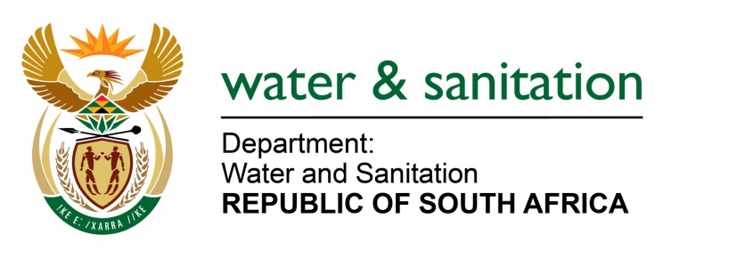

NATIONAL ASSEMBLY

FOR WRITTEN REPLY

QUESTION NO 3

DATE OF PUBLICATION IN INTERNAL QUESTION PAPER: 8 FEBRUARY 2018
(INTERNAL QUESTION PAPER NO. 1)

3. Mr W M Madisha (Cope) to ask the Minister of Water and Sanitation:
(a) What is the current status of the intended augmentation of the capacity of the Clanwilliam Dam, Voëlvlei Dam and Brandvlei Dam, respectively, (b) what has caused the postponement of the specified projects and (c) when will these projects be finalised? NW3E

---00O00---
REPLY:
- Clanwilliam Dam
Site establishment activities for the Raising of Clanwilliam Dam project commenced in June 2014 and were completed in September 2016. The remainder of the Scope of Works for the construction of the Raising of Clanwilliam Dam will be done by a private construction contractor. This contractor will be procured through a competitive bidding process is line with Government’s Supply Chain Policies and Regulations.

Berg River Voëlvlei Augmentation Scheme (BRVAS)
Trans Caledon Tunnel Authority (TCTA) has commenced with the implementation of the project. Stakeholder engagement is in progress including negotiations with the water users in order to develop offtake agreements. The procurement of the Engineering Professional Service Provider (PSP) is also in progress; the tender has been advertised and will close on 6 April 2018.

Brandvlei Dam
The final outcome of this proposed project will be an increase of the Brandvlei Dam`s canal by 30cm. This will allow and additional amount of water to be diverted during the winter months for storage which will bring an additional area under irrigation. Further phases to increase the yield can include the upgrading of the 30 year old Papenkuils pump station in the Breede River. This project is clearly linked to the National Development Plan (NDP) as well as the outcomes derived from it.

- Clanwilliam Dam
The bid for the appointment of a private sector construction contractor was issued on 26 August 2016 and closed on 9 November 2016. However, due to unavailability of funds for the construction phase of the project, the tender bid could not be awarded.

Berg River Voëlvlei Augmentation Scheme (BRVAS)
Unavailability of funding for the project delayed the project. My Department and TCTA are at advanced stage to secure funding and the National Treasury guarantees for the implementation of the project.

Brandvlei Dam
Unavailability of funding for the project delayed the project. The Provincial Department of Agriculture submitted a proposal for funding under the General Budget Support (GBS) component of the EU-funded National Development Support Programme for the first phase to raise the current canal with 30cm. No final decision was taken on the upgrading of the Papenkuils pump station.

- Clanwilliam Dam
The construction phase of the project will commence when funding becomes available. In a bid to source funding, the project was submitted to National Treasury for inclusion in the budget facility for infrastructure for strategic projects.

Berg River Voëlvlei Augmentation Scheme (BRVAS)
TCTA has adopted a fast tracked approach to project implementation and legislative requirements, including borrowing authority approvals which will result in construction commencing in October 2019 with water delivery milestone being achieved in March 2021.

Brandvlei Dam
As the DWS owns the Brandvlei Dam and associated infrastructure, they will be the lead agency responsible for the design of the infrastructure to be constructed, overseeing the construction and to identify and appoint the construction company (either in-house or externally). The Brandvlei Intergovernmental Steering Committee, consisting of 18 directly involved or affected organs of state, will oversee the implementation of this project.

---00O00---

