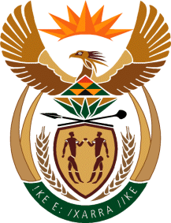

MINISTER IN THE PRESIDENCY: REPUBLIC OF SOUTH AFRICA
Private Bag X1000, Pretoria, 0001, Union Buildings, Government Avenue, PRETORIA
Tel: (012) 300 5200, Website: www.thepresidency.gov.za

NATIONAL ASSEMBLY

QUESTION FOR WRITTEN REPLY

QUESTION NUMBER: 2998

2998 Ms H Maxon (EFF) to ask the Minister in The Presidency:
With the increasing number of youth in need of financial assistance on the one hand and limited resources on the other and the waste of resources together with corruption resulting in the National Youth Development Agency applying for R4,8 million preservation orders, in respect of forfeiture of assets of employees who committed fraudulent activities, (a) why were these employees who committed fraudulent activities not arrested and (b) has the money been recovered; if not, why not; if so, how much? NW3533E

REPLY

All citizens have the responsibility to report cases of fraud and crime to the South African Police Services. The Honourable Member is encouraged to do the same. The Police will investigate and if there is sufficient evidence, they will arrest those who commit these crimes. The Courts are tasked with the responsibility to test the evidence and pass judgement regarding those who are found guilty.

