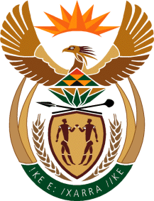

MINISTER IN THE PRESIDENCY: REPUBLIC OF SOUTH AFRICA
Private Bag X1000, Pretoria, 0001, Union Buildings, Government Avenue, PRETORIA
Tel: (012) 300 5200, Website: www.thepresidency.gov.za

NATIONAL ASSEMBLY

QUESTION FOR WRITTEN REPLY

QUESTION NUMBER: 2995

2995. Mr S C Motau (DA) to ask the Minister in The Presidency:
How many (a) government departments have established measures to combat corruption in order to comply with Management Performance Assessment Tool (MPAT) Standard Prevention of Fraud and Corruption and (b) of the specified departments comply with the specified standard at Level 3 or higher? NO3507E
REPLY:
The Management Performance Assessment Tool (MPAT) standard on prevention of Fraud and Corruption assesses whether department have measures and requisite capacity in place to prevent and combat corruption. Elements that are assessed in the standard are on:
- whether departments have fraud prevention plans and whistle blowing policies minimum anti-corruption capacity to prevent fraud and corruption;
- whether departments are providing feedback on anti-corruption hotline cases to the Office of the Public Service Commission (OPSC); and
- whether disciplinary and criminal procedures are being instituted where fraud and corruption occurs.
- Whereas the 2014 MPAT assessments results are in the process of being finalised, the 2013 results showed a total number of 55 departments (25 national and 30 provincial) are compliant with this standard.
- The 2013 results also shows that twenty five (25) departments (11 national and 14 provincial) met the level 3 compliance requirements, whilst 30 exceeded the requirements (14 national and 16 provincial).

