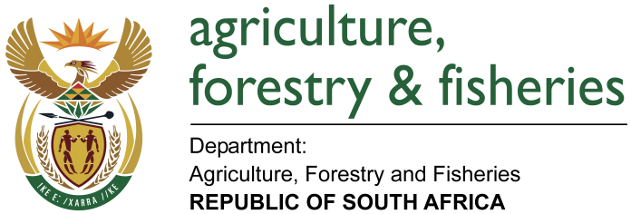
NATIONAL ASSEMBLY

WRITTEN REPLY

QUESTION 2992 / NW 3311E

MINISTER OF AGRICULTURE, FORESTRY AND FISHERIES:
Ms SP Kopane (DA) to ask the Minister of Agriculture, Forestry and Fisheries:

QUESTION:
(1) What is the (a) total amount that was paid out in bonuses to employees in his department and (b) detailed breakdown of the bonus that was paid out to each employee in each salary level in the 2016-17 financial year;

(2) What is the (a) total estimated amount that will be paid out in bonuses to employees in his department and (b) detailed breakdown of the bonus that will be paid out to each employee in each salary level in the 2017-18 financial year? NW3311E
REPLY:
- What is the:
(a) Total amount that was paid out in bonuses to employees in his department and?
Department of Agriculture, Forestry and Fisheries spent R25, 327, 000.00 on performance bonuses.

(b) Detailed breakdown of the bonus that was paid out to each employee in each salary level in the 2016-17 financial year;
Below is the breakdown of the employees who were paid bonuses in the 2016-17 financial year for 2015-16 performance:

Salary band | Beneficiary profile |  | Cost
 | Number of beneficiaries | Number of employees | % of total within salary bands | Total cost  (R’000) | Average cost per employee | Total cost as % of the total personnel expenditure
Lower skilled (levels 1-2) | 124 | 1 387 | 8.9 | 777 | R6 266 | 0.9
Skilled (levels 3-5) | 335 | 1 199 | 27.9 | 2 864 | R8 549 | 0.7
Highly skilled production (levels 6-8) | 554 | 1 637 | 33.8 | 9 500 | R17 148 | 1.5
Highly skilled (levels 9-12) | 392 | 1 111 | 35.3 | 12 186 | R31 087 | 1.9
Total | 1 405 | 5 334 | 26.3 | 25 327 | R18 026 | 1.2

- What is the:
- Total estimated amount that will be paid out in bonuses to employees in his department and?
In terms of the Department of Public Service and Administration Incentive Policy Framework departments should budget 1.55 of the annual remuneration budget for performance incentives. The Department of Agriculture, Forestry and Fisheries 1.5% is R30, 121,800.00

- Detailed breakdown of the bonus that will be paid out to each employee in each salary level in the 2017-18 financial year?
In terms of the Public Services Regulations, 2016 as amended the head of department shall ensure that the outcomes of the annual performance assessments are implemented by 31 December of the financial year following the year of assessment. The department his currently finalising the process 2016/17 performance assessments report.

